CURRICULAM VITAE  Of  BIKAS CHANDRA BISWAS | 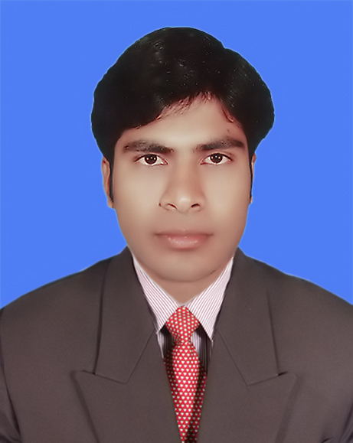
Address: Uthali, Shibaloya, Manikgonj,
Dhaka.
Mobile : 01720172224, 01995519349.

Career Summary:
To explore the opportunities and work hard for personal & organizational development and achievement
through professionalism, enthusiasm and honesty.

Employment History:
Total Year of Experience : 4.4 Year(s)

- Computer Operator :-(July 2016-Running

Unifill Composite Dyeing Mills LTD.
Company Location: Gobindabari, Kashempur, Gazipur, Dhaka.
Department: Quality.
- H.R Admin:- (June 2014 – June 2016)
Aman Graphics & Design Ltd.(Washing)
Company Location: Hematpur, Savar, Dhaka.
Department: Human Resource

Academic Qualification:
Name of Exam | Group/Subject | Result | Years | Board/University
S.S.C | Business Studies | 2.50 | 2006 | Dhaka
H.S.C | Business Studies | 2.70 | 2008 | Dhaka
Degree | B B S | 3rd | 2014 | National University

Career and Application Information:
Looking For | : | Mid-Level Job.
Available For | : | Full Time.
Preferred Job Category | : | Garments, Textile Mill, Developing Institution, IT Communication.
Preferred District | : | Anywhere in Bangladesh.

Extra-Curricular Activities:
*Strong Communication skill, *Excellent Presentation skill and leadership quality, *Motivated and flexible
mentality to the own organization, *Ability to work under pressure, *Self-motivated and excellent
teammate, *Hard working.

Computers Skills: MS Office Program, Computers’ Program of Hardware And Software,
Photoshop, Data Entry Posting, Payroll.

Language Proficiency:
Language | Reading | Writing | Speaking
English, Writing and speaking | Medium | High | Medium
Bangali, Writing and speaking | High | High | High

Personal Details :
Father's Name | : | Atul Chandra Biswas
Mother's Name | : | Kalaboti Rani Biswas
Date of Birth | : | 3rd April 1989.
Gender | : | Male
Marital Status | : | Married
Nationality | : | Bangladeshi
National Id No. | : | 19895617883979959
Religion | : | Hindu (Sonaton)
Permanent Address | : | Vill:-Katrasin, Post:-Uthali,P.s:-Shibaloy, Dist:Manikgonj, Dhaka.
Current Location | : | Vill: Gobindabari, Kashempur, Gazipur, Dhaka.

Reference (s):

Reference: 01 Reference: 02

Name : Sridam Kumar Biswas Md.Bellal Hossain
Organization : Hoshen Group Unifill Composite Dyeing Mills Ltd.
Designation : Quality Manager Washing Manager
Address : Tongi, Gazipur. Gobindabari, Kashimpur, Gazipur.
Mobile No- : 01747509253 01712880938
Relation : Brother Professional.

Signature with Date:

(Bikas Biswas)

