BISWAJIT BISWAS
  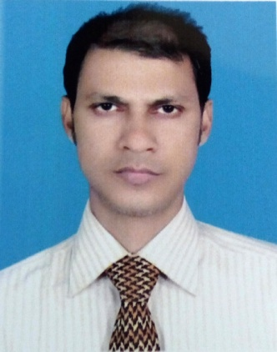
Address :House No-416/417, Amin Bhaban, Eidgha barof kol,
Halishahar,Double Mooring, Chattogram
Mobile No 1: 01637512897
Mobile No 2 :01816240905

Career Objective:
Intend to work as an efficient employee in a reputed Organization that demand hard work, innovation and strong sense of responsibility. Provides excellent working environment and ample opportunities for career development.

Career Summary:
I have 20 years’ experience in garments industry. During the tenure of my job I worked in various section like production, product development, quality etc.

Special Qualification:
I am skilled in Tuka tech and Gt Cad software. I know manual Pattern making and grading also. I know winda.

Employment History:
Total Year of Experience: 20.6 Year(s)
1. | Pattern & Garments technician ( February 11, 2018 - 2019) Till
Albion uk ltd.
Company Location: Lalkhan bazar/Chittagong
Department: buying office.
Duties/Responsibilities:
Bulk production Quality check & follow-up
Follow up sample making/Quality
Pattern Designing/Technician
Comments Review pattern adjust
Follow up production start to ship
in line check & measuring
2. | Cad and Pattern (exj) ( July 14, 2012- December 10, 2018)
Fergasam BD LTD
Company Location: C E P Z
Department: Sample Section
Duties/Responsibilities:
Develop pattern to Bulk Follow up Follow up sample making/check Quality according to buyer comments. Bulk production Quality check & follow. Follow up pattern grading According to buyer comments pattern adjust.

3. | Pattern and Sewing Technician. ( September 8, 2005 - March 27, 2012)
Regency Garments LTD.
Company Location: Chittagong Export Processing Zone
Department: Sample and Technician Department
Duties/Responsibilities:
According to buyer sketch how to easy make production analysis. Make pattern as per buyer required. Follow up Quality and Measurement also. Follow up size set also. Follow up production.
4. | Pattern Master & Sample QC ( August 20, 1996 - April 30, 2004)
Azim Manan Garments Ltd.
Company Location: Kalurghat Heavy Industry Area.
Department: Sample Section.
Duties/Responsibilities:
Manual Pattern making and grading also for sample making and production. Check Quality and measurement b/4 send sample to buying office. Follow up production and in line check also.

Academic Qualification:
Exam Title | Concentration/Major | Institute | Result | Pas.Year | Duration | Achievement
Bachelor of Science (B.Sc.) | Science | National University | Second Class, Marks :4.77% | 1995 | 1993 - 1994 | Comilla Board
HSC | Science | Quash Sheikh Mohammed Degree College | First Division, Marks :4.96% | 1992 | 1990 - 1991 | Comilla Board
SSC | Science | South Madarsha SS High School | Second Division, Marks :4.76% | 1990 | 1989 | Comilla Board

Career and Application Information:
Looking For | : | Mid Level Job
Available For | : | Full Time
Present Salary | : | Tk. 60000
Expected Salary | : | Tk. 80000
Preferred Job Category | : | Garments/Textile, Garments technician/Machine operator, CAD Operator
Preferred District | : | Anywhere in Bangladesh.

Specialization:
Fields of Specialization | Description
- Garment Designing  - Pattern Designing  - Follow up sample making to ship  - comments Review&pattern adjust  - garments fitting check also  - Quality improvements  - Root Cause Analysis | Garments technician and Quality technician

Language Proficiency:
Language | Reading | Writing | Speaking
Bangla | High | High | High
English | Medium | Medium | Medium

Personal Details :
Name  Father's Name | :  : | Biswajit Biswas  Late Monoranjan Biswas
Mother's Name | : | Late Supriya Biswas
Date of Birth | : | September 29, 1971
Gender | : | Male
Marital Status | : | Married
Nationality | : | Bangladeshi by Birth
National Id No. | : | 1007392929
Religion | : | Hindu
Permanent Address | : | Vill-Bathua, Po- Nur Ali Bari (4337), P.S -Chittagong, Nur ali bari, Hathazari, Chattogram 4337
Current Location | : | Chattogram

I do hereby declare that the information stated here is correct to the best of my concern.

Biswajit Biswas

