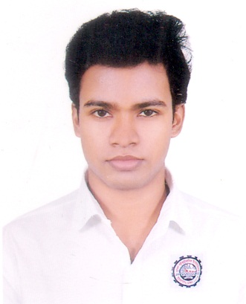
CURRICULUM-VITAE

DIN MOHAMMAD AKASH
Current Address:
142/1 Free school Street Kathal Bagan Dhaka 1205, Bangladesh
Cell: +8801741515702 E-mail: akash335522@gmail.com

Career  Objective | To obtain an engineering position, utilizing technical skills developed through experience and education with the opportunity for advancement in the area of engineering management.

Scholastic  Records | Engineering  Institution name  Year of passing  CGPA | : Diploma in Refrigeration and air conditioning Technology  : Dhaka polytechnic Institute  : 2020  : 8 Semester running
Scholastic  Records | School  Board  Group  Year of passing  CGPA  Class nine CGPA | : Adarsha high School, Dhaka  : Bangladesh Technical Education Board Dhaka  : Food Processing and Preservation  : 2016  :4.32 in a scale of 5.00  :4.38 in a scale of 5.00

Employee History | Company Name : NB International  Location : House - 17 Flat – CE4, Road – 5 Dhanmondi Dhaka  Position Held : Sales, marketing and Service Engineer  Department : Online marketing  Duration : 8th January, 2020 to till Date.

Training Summary  Visit & Working | Institute : G Tech Solution Ltd  Title : Industrial Attachment  Duration : 06 Months  Institute : Mymensingh Agro Limited  Title : Machinery repair  Duration : 10 Days

Computer  Literacy | Data Processing & Editing Package : MS Word, MS Excel.  Presentation : MS Power Point.  Other Specialty : Internet Browsing, mailing, etc.

Language  Proficiency | Language Writing Reading Speaking  Bangla Excellent Excellent Excellent  English Good Good Good  Hindi No No Good

`Reference:
Name |  |  |  | : | Harunur Rashid
Organization |  |  |  | : | NB International
Designation |  |  |  | : | Visit, Sales and Service Engineer
Address |  |  |  | : | Dhanmondi, Dhaka
Mobile |  |  |  | : | +8801970426337
E-Mail |  |  |  | : | t.nbintl@yahoo.com
Relation |  |  |  | : | Professional

Extra Curriculum Activities:
Electrical: Repair, Light, Fan and switch board
Electronics: Repair, TV, LED TV and laptop

Personal Details:
Fathers Name: MD Abdul Kashem
Mother Name: Rokeya begum
Date of Birth: 4 DEC 1997
Gender: male
Marital Status: Unmarried
Nationality: Bangladesh
Religion: Islam

I, the undersigned, certify that to the best of my knowledge and belief, these curriculum vitae correctly described.

…………………………….
Din Mohammad Akash

