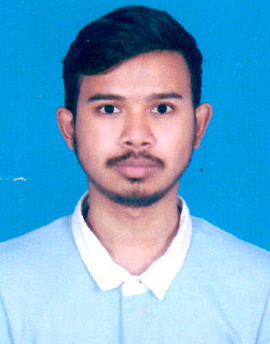
Curriculum Vitae
Dibakor Talukdar
House #102(Rasheda House)
Sonar Bangla R/A, Bagbari, Sylhet.
Mobile: +8801730661971
Email: Dibakor07@gmail.com

Career Objective
I would like to build a fascinating career in a dynamic and diverse environment using my knowledge and attitude with passion, confidence and honesty.

Academic achievement
Name of Exam | Board/University | Passing year/ Session | Obtained GPA/CGPA | Group/ Major
M.A.(Master’s) | Leading University | On Going | On Going | English Literature
B.A. (Hon’s) | Sylhet International University | 2018 | 3.58 | English Literature
H.S.C | Sylhet | 2013 | 3.70 | Science
S.S.C | Sylhet | 2011 | 4.56 | Science

Computer Skill
- Office Software: Windows XP, 7, 10
- Office Software: MS Office (Word, Excel & Power Point)
Language Skill
- Bengali: Native
- English: Good in Speaking, Reading and Writing. (Scored 6.5 in IELTS exam)
- Hindi: Intermediate in Speaking.
Extra-Curricular Activities
- Joint General Secretary at Sylhet Debate Federation, (2017 to 2018)
- Joint General Secretary at Chorjapath, (2016 to 2018)
- Member of SIU-Cultural Club.(2014 to Present)
Participation
- IELTS Exam, 28th October, 2017.
- ICT Debate Festival, Sylhet Division, 2015-2016.
- Science Fair at TNO Office, 2008.
- National Debate Championship by SUST-SD, 2016.
- SDF 2nd Divisional Debate Festival, 2018
Traning
- Workshop on Debate: How to and What to (Sylhet Debate Federation), 2016
- Workshop on Traditional Debate (Sylhet Debate Federation) 2016
- Workshop on Parliamentary Debate (Sylhet Debate Federation) 2016
- English language Teachers Development Program by BELTA, 2018.
Personal Details
Name : Dibakor Talukdar
Father's Name : Digendra Kumar Talukdar
Mother's Name : Mousumi Rani Samonta
Permanent Address : Vill: Karuajan, P.O: Faruknagar,
P.S: Madhyanagar, Dist: Sunamganj.
Present Address : Vill: Khidrakapon, P.O: Jawa Bazar,
P.S: Chattak, Dist: Sunamganj.
Date of Birth : 30.08.1995
Religion : Hindu
Marital Status : Unmarried
Nationality : Bangladeshi (By Birth)
Gender : Male
Reference

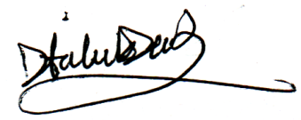
Signature

Date:
(Dibakor Talukdar)

