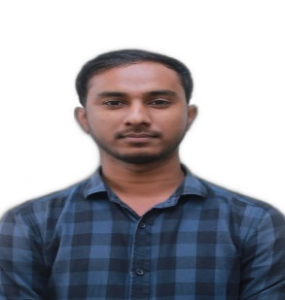
MD. IKBAL HUSEN CHOWDHURY
Address: 12/A Husnabad, Shahi-Eidgah, Sylhet.
Mobile: +88 01771291600
E-mail: iqbalchowdhury600@gmail.com

Career Objective
Four-year university life, I acquired knowledge which will help me to achieve my dream. I have Participated few programming contest (online and onsite) and developed some basic web app and android app in trended technology. I love to learn new stuff and working on challenging problems. I have experience in HTML, CSS, PHP, Bootstrap, MYSQL and much more that needs a web developer.

Academic Qualification:

Degree Title | Major | Institution | Result | Pass Year
B.Sc. (Engg.) | CSE | Leading University, Sylhet | CGPA: 3.35 out of 4 | 2018
HSC | Science | Shahjalal City College, Sylhet | GPA: 4.30 out of 5 | 2014
SSC | Science | Baktherpur A.K High School | GPA: 4.81 out of 5 | 2012

Key Skills

- Languages: Basic C, C++, Java, PHP.
- Framework & Library: Bootstrap.
- Database: MySQL.
- Layout: HTML, CSS.
- Photoshop: Adobe Photoshop (Basic).

Projects done
- Bus Ticket Booking – Android app
- Workflow Management System – Web Based

Achievements

- Participated some social activities as well as sports activities.
★IELTS: 6.

Extracurricular Activities

- Member at Leading University Computer Club.
- Member at Leading University Debating Club.
- Member at Leading University Cultural Club.
- Member at Leading University Sports Club

Personal Details:

Father’s Name: Late Salak Ahmed
Mother’s Name: Safia Begum
Date of Birth: Oct 8, 1995
Gender: Male
Nationality: Bangladeshi
Religion: Islam
Permanent Address: Kalierbhanga, Nabiganj, Habiganj.

References:
Rumel MS Pir
Assistant professor Computer science & Engineering, Leading University.

