Jasim Uddin, FCMA
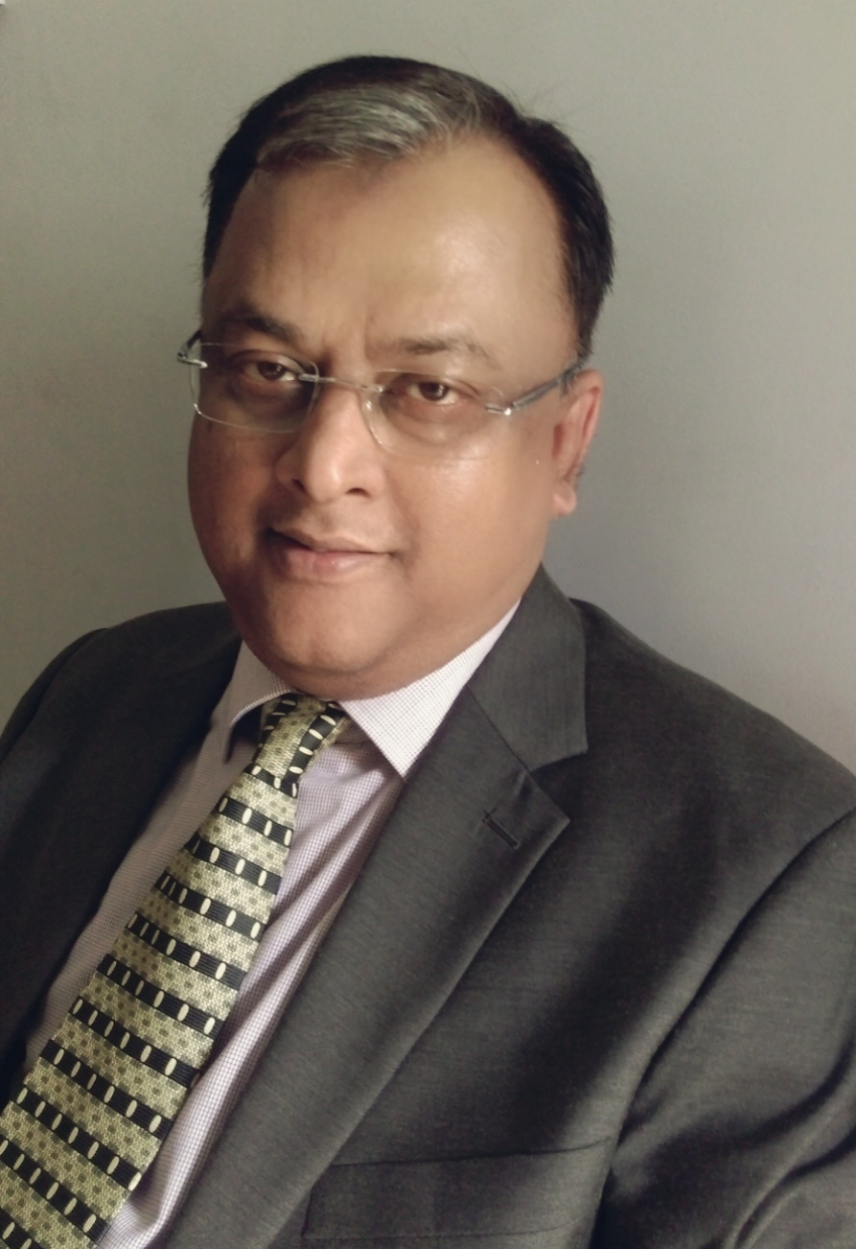
Apt #A4, House # 43, Road # 14/3, Block # G, Niketon, Gulshan
Mobile: +88 01711500069; Email: jasimuddinfcma@gmail.com

Proactive, goal-oriented senior executive with extensive international financial management and operations experience. 14 years of experience as a CFO has proven the ability to articulate vision, strategy or idea clearly and thrive in a fast-paced business environment. Experience in financial analysis/reporting/controlling, continuous process improvement, internal controls, supply chain management and people management.

CORE LEADERSHIP STRENGTHS
Financial Planning & Analysis
Cash Flow Management
Financial Operations & Control
Strategic Change Management

Leadership & Team Building
Project Management
Staff Development and Training
Process and System Optimization

Leadership Knowledge:
Management Development Course at University of St.Gallen, Switzerland
Senior Management Program at IMD - Lausanne, Switzerland
Leadership Assessment & Development Program at PDI, Singapore
Senior Leadership Program at IMD - Lausanne, Switzerland

PROFESSIONAL HISTORY
Siam City Cement (Bangladesh) Limited  Director Finance  [Siam City Cement is a Thai base cement manufacturing company regionally in Asia having plant in 6 countries including Bangladesh] | Jan’17 - till date
Summit Communications Limited  CFO  [Summit Communications Limited is a leading end to end infrastructure support provider having Nationwide Telecommunication Transmission Network and Gateway licenses.] | Jun’15 - Dec’16
Amin Mohammad Group  CFO  [Amin Mohammad Group is one of the Country's leading Real Estate & Land Development organization] | Feb’14-May’15
Freelance Consultancy  [Worked with different organizations like Super Star Group (Electrical Accessories Manufacturing organization), Shovon Group (Packaging Industries) to restructure the organizational, financial & other functional areas] | April’11-Jan’14
Holcim (Bangladesh) Limited  CFO  [Holcim is a Switzerland base largest cement manufacturing company worldwide having plant in 74 countries including Bangladesh] | Feb’03-Apr’11
Grameenphone Limited  Deputy General Manager, Accounts  [Grameen Phone Ltd. is the largest GSM Mobile Telephone Operator Company of Bangladesh] | Jan’97-Jan’03
TECHNO FOCHI (BD) LTD.  Accounts Officer (Head of Accounts)  [Techno-Fochi (BD) Ltd. is a Joint Venture Construction Company (Electrical & Mechanical) of Fochi Group of Italy {70%} & Technocon Ltd. of Bangladesh {30%}]. | Mar’93-Dec’96
Mir Akhter Hossain LTD.  Accountant  [Mir Akhter Hossain Ltd. is one of the country’s largest Construction Company – Worked at Feeder Roads Improvement Project (A Joint Venture Project with SAMWHAN CORPORATION of South Korea)] | Feb’90-Mar’93

KEY RESPONSIBILITIES MET

- Ensure Group/Organization Financial policies for control and procedures
- Preparation of Business Plan, Annual budget and Financial Forecasting
- Supervise in preparation of monthly, quarterly & annual financial reports
- Effective fund management by managing good banking relationships
- Negotiate all Forex rates
Finance, Controlling & Taxation Tasks

- Manage all aspects of corporate taxation through prompt and accurate tax issues
- Managing effective VAT operation
- Review regular insurance portfolio for security purpose
- Coordinate credit facility to customers and approve credit limit
- Coordinate external audit local and overseas;

- Ensure Raw material sourcing and shipping arrangement
- Negotiate with agents on long term contract
Supply Chain Management & Logistics Support Related Tasks
- Co-ordinate all inward logistics activity
- Approve all PO/WO as functional responsibilities
- Supervise, coordinate & negotiate for all spare parts procurement activity
- Participate as a decision maker in all Capex & Opex related activity;

- Scope of diverse responsibilities in Human resource and administration
- Responsibility of staff training and development as Key person
- Participation as MTM in all decision making activity
Others
- Member of PFA committee member, Gratuity Fund member
- Co-ordinate all company secretarial work
- Supervise IT related Works;

TRAINING EXPERTISE
- Continuing Professional Education Program organized by ICMAB science 1993
- Training on Fundamentals of leadership organized by Ericsson Academy (Malaysia), 2001
- Training Course on International Roaming for GSM Mobile Phones organized by Dannet of Denmark, 1998
- Training on Web-based financial reporting organized by Telenor at Oslo, Norway, 2000
- Holcim Business Planning workshop at Bangkok, 2003
- Management Development Course customized with Holcim Business Model by University of St.Gallen, Switzerland , 2004
- Financial Reporting Workshop at Zurich, Switzerland organized by Holcim, 2003 & 2005
- Finance & Controlling Workshop 2003, 2004, 2005, 2006, 2007, 2008 & 2010 organized by Holcim at Zurich, Switzerland, at Ho Chi Minh City, Vietnam, at Manila, Philippines, at Jakarta, Indonesia, at Mumbai, India, at Stein am Rhein, Switzerland and at Singapore
- Regional Leadership Seminar at Cambodia, 2005 and Leadership Workshop at Dubai, 2008 organized by Mckinsey & Company
- Seminars/Workshops organized locally by Rapport, Track Training, Stamford University etc.
- Senior Management Program (SMP) a special customize management course for Holcim Top level executives at IMD - the renowned international business school in Lausanne, Switzerland, 2006.
- Leadership assessment program organized by PDI, Singapore, 2007
- Senior Leadership Program (SLP) a special customize leadership course organize only for senior and selected top executives of Holcim at IMD - the renowned international business school in Lausanne, Switzerland, 2008;

EDUCATION AND PROFESSIONAL QUALIFICATION HISTORY
Cost & Management Accountant  (Membership in ICMAB # F0298) | 1993
M.Com  Accounting | 1988
B.Com | 1986

REFERENCE
Mr. Adeeb H. Khan, FCA  Partner  KPMG Rahman Rahman Huq  9 Mohakhali C/A, Dhaka.  Phone: 9886450-2  Mobile 01611311872  Email: adeebkhan@kpmg.com | Mr. N K A Mobin, FCA,FCS,CFC  Managing Director  Emerging Credit Rating Ltd.  SHAMS Rangs, Baridhara, Dhaka.  Phone: 9860911  Mobile : 01711500387  Email:mobin@emergingresource.com | Mr. P N Iyer  Managing Director  Siam City Cement (Bangladesh) Ltd.  Plot 52, (7th Floor) Road 11, Block C.  Banani, Dhaka  Mobile: 01711539906,  Email: pn.iyer@siamcitycement.com

PERSONAL INFORMATION

Date of Birth | 15 February, 1966
Nationality | Bangladeshi by Birth
Religion | Islam
Marital Status | Married
Father’s Name | Mr. Mohammed Ali
Mothers Name | Ms. Jahanara Begum

__________________________
Jasim Uddin, FCMA

