CV Khaled Hussain
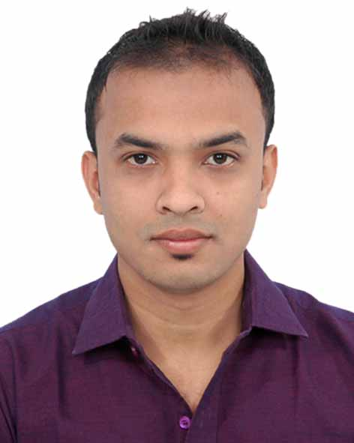
PERSONAL INFORMATION__________________________________________________
Name : Md.Khaled Hussain
Fathers name : Md. Aftab Uddin
Mothers name : Mrs.NeelufarYasmin
Date of Birth : 31.05.1994
Nationality : Bangladeshi.
Permanent Address : Vill:Kalaiura, P.O: Jaldhup. P.S: Beanibazar,
Dist:Sylhet.
Current Address : Mohini,Lamapara.Shibgang, Sylhet.
Mobile : 01737411487
Email : khaledraj1994@gmail.com
NID Number : 19949111751000144

OBJECTIVES________________________________________________________________
Achieving a dynamic and challenging job where I could use my educational, professional and interpersonal skills that will add desired value to your organization and develop my career with the best effort. EDUCATION_____________________________________________________________________
2014 – 2017 B.Sc. in computer science.
Leading University, Sylhet.
- Grade achieved:3.05/4
- Relevant courses: Accounting, (M I S), Economics, DSP, Sociology, Bangladesh studies.
- Project: Android based apps “Kid’s Environment” and “food rating and reviews” and also done a web based project successfully.
2010– 2012 H.S.C
Jalalabad Cantonment Public School And college,Sylhet.
- Grade achieved: A+(Golden)
- Group: Science
- Optional subject: Math.
- – 2010 S.S.C
Shahjalal Jamia Islamia School And college,Sylhet.
- Grade achieved: A+(Golden)
- Group: Science.
- Optional subject: Computer science.

PROFESSIONAL EXPERIENCE____________________________________________
- Lecturer (ICT). Greenhill State College,Shibgong,Sylhet. From December 2018 to running.
- I have teached as a part time lecturer of ICT at Dasherbazar Degree College in Barlekha from Septembar 2017 to Februray 2018 .
- I have worked as a computer operator in a private company.
EXTRACURRICULARACTIVITIES________________________________________
- Member of computer club in leading university.
- Member of sports club in leading university.
- Member of debating club in school life.
- Regular member of Sylhet cycling society.
SKILLS___________________________________________________________
- HTML, HTML5, CSS, CSS3.
- As a computer science student I have basic knowledge of all programming language.
- Have knowledge in Microsoft office (word, excel), power point, Photoshop, database.
- Good at English Language.
.INTERESTS & ADDITIONAL INFORMATION_______________________
I love cycling .I like travelling by cycle in natural place. Playing cricket is one of my favourite things. Cooking delicious food also like References_____________________________________________
- Bazlul Halim Bidrohee
Lecturer, Chattak Degree College, Chatak, Sunamgonj.
Address: Kharadipara,Shibgang,Sylhet
Tel: 01730-909707
- Proshanta kumar Saha
Principal
Greenhill State College, Sylhet.
Address: Gupaltila,Tilagor,Sylhet.
Tel: 01711-289711
Md.Khaled Hussain
Signature& Date

