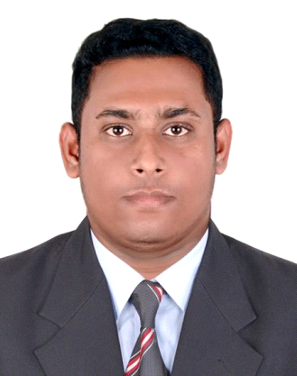
Personal Information

Full Name - ABU OMAR MOSTAFA KAMAL
Address - 735/A, Khilgaon, Dhaka-1219.
Cell phone no - 01675957540
Email - mkbappy66@gmail.com
Date of Birth - 20-September-1992
Marital Status - Single
Religion - Islam
Nationality - Bangladeshi

Career Summary:
Banking personnel, with priorexperienced in-customer relationship management, record management, sales, collection & recover, query management, card operation etc. Other than above, I prefer to be well organized, courageous, result driven and passionate to go extra miles forsolutions.
Tend to be focused in creating a function able & professional working environment in work place. Fortunately, have worked in operation & business line both and aim to make a successful career in banking industry.

WorkingExperience:
Name of Employer Bank Asia Ltd
Designation & Duration ARO, Collection & Recovery, Card Operations (May’17 to Feb’18)
Roles & Responsibilities-

- Collection and Recovery efforts and increase your accounts receivable by identifying accounts with the highest payment potentialand verify all documents received from prospectus clients.
- Analyzing industry practice and adapting new strategies.
- Maintain individual portfolio of clients and necessary data as a MI for any time actionable
- Time to time share guidance to field representative to facilitate the collection within set TAT.
- Follow up clients to maintain recovery of total portfolio of the respective person within due date.

Cost Minimization
Rolled out this project with my line manager to make our department cost minimization champion. Wherein we have initiated to migrate all our departmental hard copy record retentions into soft copy MI (electronic record) by scanning.

Record management
Managed to maintain departmental on-site & off-site records. Throughout this project I have developed my knowledge on documentation, database management skills, accuracy and so on.

Name of Employer The City Bank Limited
Designation & Duration TPMO, Retail Banking Division (Jun’16 to Apr’17)
Roles & Responsibilities-

- Meet business targets and offer appropriate products to client- PL, Auto loan, Home loan etc
- Collect and verify all documents received from prospectus clients.
- On-board NTB clients as per bank regulations and ensure necessary due diligence.
- Maintain healthy relationship with clients and attend time to time business calls.
Training & Development Workshop

- Participated on 3 day long training course on “Introduction of Banking”:by BIBM.
- Attended several in-house training in Bank Asia during tenor with card operation.

Academic History .

M.B.A in Marketing
Institution Name : Habibullah Bahar University College, Dhaka (2014)
Result (CGPA) : 3.09 (out of 4.00)

B.B.A (Hon’s) in Marketing
Institution Name : HabibullahBahar University College, Dhaka (2013)
Result (CGPA) : 2.70 (out of 4.00)

Higher Secondary Certificate (H.S.C) in Business Studies
Institution Name : Bangladesh Commerce College (2009)
Result (CGPA) : 3.50 (out of 5.00)
Secondary School Certificate (S.S.C) in Business Studies
Institution Name : Khilgaon High School (2007)
Result (CGPA) : 3.38 (out of 5.00)

Computer Proficiency.

MS Word (expert),MS Excel (Advanced), MS PowerPoint (expert),Database Management.

Interests .

Traveling, reading International Affairs, social development work, new innovations etc.

Language Skills .

Proficiency on English & Bangla reading, writing and spoken skills

Reference .

Available upon request.

I hereby, confirm that the abovementioned information’s are authentic & correct.

.....................................................
Abu Omar Mostafa Kamal

