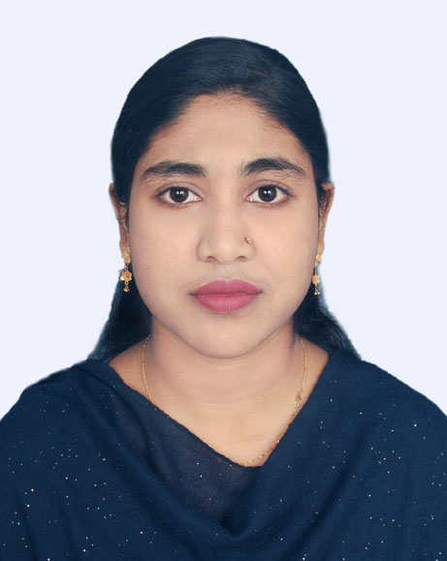
Farzana Taharun
Ka-146, Kuril, Vatara
Dhaka-1229
E-mail: farzana.mintu@yahoo.com
Cell no: 01969393361

Career Objective:
To secure a career in a reputed organization, which appreciates professional approach and hard work, where I can utilize my knowledge, various skills in contribution towards fulfilling the company’s growth objectives.

Work Experience:
Completed internship program for 6 months from National Bank Limited, where I was responsible for account opening, handling customers queries, maintaining NID verification register and verifying the signature of customers.

Academy Qualification:
Bachelor of Business Administration
Name of the institution : Uttara University
Concentration : BBA (Major in HRM)
Year of the pass : 2018
Result : CGPA 3.56

Higher Secondary School Certificate (H.S.C)
Name of the college : B.A.F Shaheen College, Kurmitola
Concentration. : Science
Year of pass. : 2014
Result : GPA 5.00
Board : Dhaka

Secondary School Certificate (S.S.C)
Name of the School : Kurmitola High School
Concentration : Science
Year of pass : 2012
Result : GPA 4.88
Board : Dhaka

Computer Skills:
- MS Word, MS Excel, MS Power Point,
- Mail Corresponding, Internet browsing
- Have competency to adapt any type of software.
- SPSS

Extracurricular Activities:
- Self Driving.
- Volunteered in annual sports in school and college level.
Language:
Excellent at reading, writing, speaking and listening English and Bangla.
Personal Information:
Father’s Name : Abul Kashem Azad
Mother’s Name : Shamsunnahar Azad
Date of birth : 15 March 1997
Religion : Islam
Nationality : Bangladeshi

Reference:
MD. Anisuzzaman
Assistant Professor & Director
Center for Career Development (CCD) - SOB
Uttara University
N.Z Center (6th floor), House-5, Road-12, Sector-6, Uttara, Dhaka -1230, Bangladesh
Phone: 880-2-58951116, 58955794
E-mail: komol0709@gmail.com

Md. Atiqur Rahman
Officer- Share Department
British American Tobacco Bangladesh Company Limited
Phone: 01755532753
E-mail: atiqur_rahman@bat.com

Declaration:
I, Farzana Taharun state that, the information compiled above is precise and accurate in its entirety.
