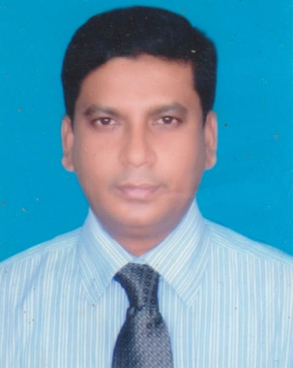
Resume
Of

MD. AURANGAZEB

Contract Address:

Srayoshee Tower (4th Floor), Plot-07, Main Road-03,
Mirpur-10, Dhaka-1216, Bangladesh
Cell Phone: 01819-240981

.

Aim and Objective

Searching a job where I can apply my academic knowledge and obtained past job experience to the pursue of professional career in any renowned business sector to provide an excellent job environment where quality performance, creativity will be recognized and rewarded.

Educational Qualification

- Secondary & Higher Secondary Education from Comilla Education Board under
Comilla Cantonment High School and Comilla Victoria Govt. College.
- Graduation and Post-Graduation from Dhaka University under
Finance & Banking Department.

Job Experience

a) 1992-2002 Sonali Bank Ltd. Start Job as a Probationary officer at Imamgonj Corporate
Br. at Puran Dhaka, and retired from Khulna Corporate Branch as Sr. Principle Officer.
b) 2002- 2008 Samrat Group, Narayangonj Started job as an Accounts Officer and finally I was there Accounts Manager when I leave the job.
c) 2009- 2014 Silk Group, Dhanmondi, Dhaka, as a General Manager.
d) 2014- up to now in Dhaka based well reported Export Import Company as an Executive Director.
*15 years more than job experience in Export Import related field and can able to do any sorts of task in Import & Export business.

Language Proficiency

Bengali : Mother tongue
English : Fluent in writing, listening and speaking.

Personal Profile

Sl. | Particulars | Detailed Information
 | Name | Md. Aurangazeb
 | Father’s name | Md. Sanwar Ali
 | Mother’s name | Sufia Khanum
 | Date of birth | 30th October 1968
 | Gender | Male
 | Contact number | 01819-240981
 | Permanent address | Village & Post. – Angiadi, Thana- Pakundia, Dist. - Kishoregonj.
 | Nationality | Bangladeshi by birth
 | Religion | Islam.
 | Marital status | Married.

Personal Characteristics

Self-Confident, Hard Worker, Strong Analytical and Leadership Skills, Excellent Interpersonal and Communication Skills

Interest & Hobbies

I am interested to to see Cricket and Football match.

[

Signature & Date

(Md. Aurangazeb)

