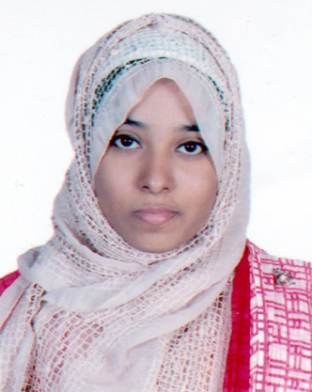

Sadia Mahbuba Chowdhury

Mailing Address:

House No: 29/5 Prantik Subidbazar,Sylhet.
Contact no: 01686580198 / 01798026995
E-mail:sadiachowdhury32@gmail.com

CAREER OBJECTIVE
To be an astute learner and the best performer in your organization so that I can build an innovative career in your esteemed organization by using my skills and other significant talents.

ACADEMIC QUALIFICATIONS

Exam Title | Major | Institute | Result | Year of Passing | Duration
MBA | HRM | Metropolitan University Sylhet. | CGPA:3.84(Up to 2nd semester} | 2019 | 1 year
BBA | Management | Metropolitan University Sylhet. | CGPA: 3.96/4 | 2018 | 4 years
Higher Secondary Certificate (H.S.C.) | Commerce | Sylhet Commerce College. | GPA: 5.0/5.0 | 2013 | 2 years
Secondary School Certificate (S.S.C.) | Commerce | Blue Bird School and College Sylhet. | GPA: 5.0/5.0 | 2011 | 2years

COMPUTER SKILLS
- Microsoft Office: MS Word, MS Excel, and MS Power Point

PERSONAL SKILLS
- Excellent written and verbal communication skills
- Highly organized and efficient
- Ability to work independently or as part of a team
- Proven leadership skills and ability to motivate

INTEREST
- Traveling
- Attending Seminars

EXTRA CURRICULUM ACTIVITIES
- Won many medals at school, college and university level
- Active participation in plays/drama at college level

PERSONAL DETAILS
Father’s Name : Mohobubul Kadir Chowdhury
Mother’s Name : Rowshan Ara Chowdhury Juthi
Date of birth : 22 December, 1994
Marital Status : Single
Nationality : Bangladeshi

REFERENCES

- DR. MOHAMMAD JAMAL UDDIN
Associate Professor Dept. of Business Administration
Metropolitan University Sylhet
Relation : Academic
Contact no : 01558347255
muddin@metrouni.edu.bd

2. PROFESSOR DR. KABIR HUSSAIN CHOWDHURY
Chairman Academic Council Scholarshome, Sylhet
Mobile no : 01711802141
Relation : Grandfather

DECLARATION OF AUTHENTICITY
I, Sadia Mahbuba Chowdhury, hereby declare that the above-furnished information is true to the best of my knowledge and belief.

Sadia Mahbuba Chowdhury

