CURRICULUM VITAE

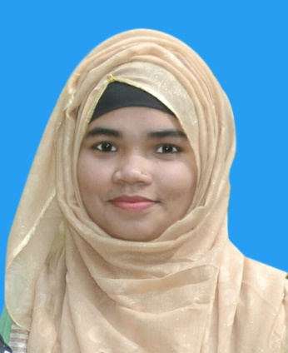

Majeda Jannat Ami Amtoil, Juri, Moulvibazar, Sylhet
Cell Phone No: 01772971488
E-mail: majedaemi@gmail.com

CAREER OBJECTIVE

As a Fresh Graduate I am highly interested to be a part of a well-established company through hard work, creativity, honesty and sincerity and finally want to be an asset in my desired position by applying my academic excellences and experiences.

EDUCATIONAL QUALIFICATION

Bachelor of Business Administration (BBA)
Institute : Metropolitan University, Sylhet
Board : Sylhet
Major : Finance and Banking
Passing year : 2018
CGPA : 3.96 (out of 4.00)

Higher secondary certificate (HSC)
Institute : T. N. K. Academy degree Collage
Board : Sylhet
Group : Business Studies
Passing year : 2013
GPA : 5.00 (Out Of 5.00)

Secondary School Certificate (SSC)
Institute : Juri Model High School
Board : Sylhet
Group : Business Studies
Passing year : 2011
GPA : 5.00 (Out Of 5.00)

Internship work Experience

30 September 2017 to  30 November 2017 | NCC Bank Limited  - Prepared an Internship report on SME Banking of NCC Bank Limited.  - Worked in a corporate environment & interacted with employees from different hierarchies in a professional environment.  - Worked in customer service department and also able to open 100 customers bank account (current and saving), 40 SSS account, 30 FDR and prepared at least 30 pay order during my internship.  - Worked in Foreign Remittance Department, usually served approximately 80 clients for remittance service in daily basis and posting these data in RMS.  - Also providing utilites services to the customer and data entry of those utilities bill.  - Successfully I achieved all the targets given by Bank Manager during my internship.

LANGUAGE PROFICIENCY

- Bengali : Excellent communication & presentation skills in Bengali
- English : Good communication & presentation skills in English

COMPUTER SKILL

- Microsoft Word and Excel
- Microsoft Power point
- Internet Browsing
- Microsoft access

OTHERS SKILL

- Ambitious, Hard working and excellent in time management.
- Great teamwork and Leadership skill.
- Able to work logically, analyze solution and come up with solution.
- Self-motivated and Confident.
- Able to work in different environment.
- Excellent Interpersonal Communication skill.

FIELD WORK ON RESEARCE PAPER

a) Customer attitude towards the fast food shop in Sylhet
b) Health hazard of mobile phone towards teenager in Sylhet
c) Measuring Satisfaction of Sim users in Sylhet
d) Measuring Satisfaction of Small and Cottage Industry’s Entrepreneur
e) Customer attitude towards the impulse buying.

PERSONAL INFORMATION

Father's name: Md. Moin Uddin
Mother's name: Mst. Sultana Akther
Present Address: Amtoil, Juri, Moulvibazar, Sylhet
Permanent Address: Amtoil, Juri, Moulvibazar, Sylhet
Date of Birth: 11 December 1996
Nationality: Bangladeshi (by birth)
NID Number: 19965813555000185
Marital Status: Single
Hobbies and Interest: Watching TV, Listening Music, Traveling and Reading books

REFFERENCES

Md. Ziaur Rahman  Manager  NCC Bank Limited  Juri Branch, Moulvibazar  Contact No: +880 1716870323 | Professor Dr. Taher Billal Khalifa  Dean  Department of Business Administration  Metropolitan University, Sylhet  E-mail: tkhalifa@metrouni.edu.bd

DECLARATION

I confirm that, to the best of my knowledge, the information given here is correct.

-------------------------------------------
Majeda Jannat Ami Date:

