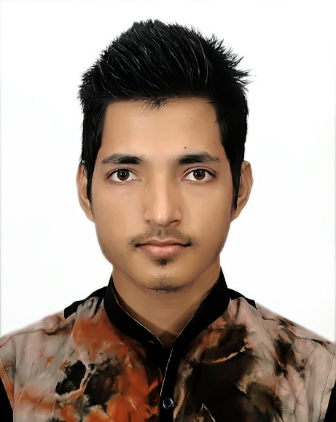
Curriculum Vitae
Of
ALI HUSAIN
Cell Phone: +880 1711-713908
Email : jkrbdy@gmail.com

Career Objective:

I would like to work in a place in such a position where I could use my interpersonal skills, creativity to prove myself efficient enough for my position. Through my job I want to serve my organization as well as country and above all my learning experience in order to develop my career as well as to contribute in any sector.
Education Attainments:

Secondary School Certificate (S.S.C):

Institute : Dhaka Uttar Muhammadpur High School
Subject : Humanities
Passing Year : 2011
Result : 3.50

Higher Secondary Certificate (H.S.C)

Institute : Syed Nabib Ali College
Group : Humanities
Board : Sylhet
Passing Year : 2013
Result : 2.0
Extra-Curriculum Activities:

- Strong analytical and leadership skills.
- Excellent interpersonal and communication skills.
- Team spirit and initiative.
- Have quality to make friendly environment with any unknown person.
- Moreover have a good knowledge about mind reading.
- Good team working and interpersonal skills.
- Ability to work efficiently under pressure.
- Competent in verbal communication.

Personal Details:

Name : ALI HUSAIN
Father’s Name : Surman Ali
Mother’s Name : Angur Begum
Date of Birth : o5th April, 1993
Religion : Islam
Nationality : Bangladeshi by Birth
Marital Status : Unmarried
Present Address : Vill: Tikorpara, P.O: Kawdiya,
P.S: Beanibazar, District: Sylhet.

Permanent Address : Vill: Kadimolik, P.O: Ramda Bazar,
P.S: Beanibazar, District: Sylhet.

Experience :

- 8 Months Working Experience as an Assistant Manager of Citycell Service Touch Point (S.T.P) Golapgonj, Nur Mansion Plaza (Oct 2014 to May 2015).

- 2 Years Working Experience as a Private Teacher (Subject-English).

Language Skills:

- Bengali Traditional : 100%
- English International : 90%
- Spanish Native : 20%

Technical Skills:
- Application Packages : Microsoft Office Programs (M.S Word, M.S Excel,
M.S Power Point) Good At.

- Operating System : Windows 7, 8, 10 To Adding Modified Feature.

- Graphics Design : Adobe Photoshop, Illustrator, Photoshop PS and CC.
- Programming Code : HTML and Python.
- Networking : LAN, WLAN, VPN, Web Design and Hosting.
- Other Skills : Software Troubleshooting Fixer, Video Editor (Pro)
And FX Creator, Windows Hacking, Live USB Creator,
Music Creation In FL Studio (Pro), Android Developer
Worldwide,

Fields Of Interest:
- Keen to interest in reading, writing creative thinking traveling,
cultural and social activities.

I the undersigned state that the information famished above am absolutely true to my knowledge.

Signature

_____________________
ALI HUSAIN

Date:

