Resume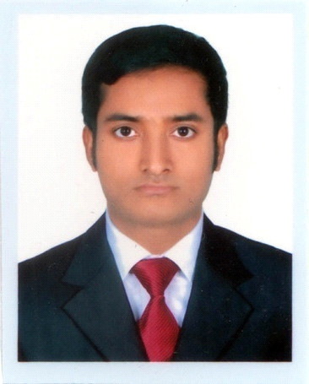
Of
Md. Abdul Hannan

Mailing Address:
146, Shahalibag,
Mirpur-01, Dhaka-1216.
Mobile No: 01789789384.
Email: gazihannan2525@gmail.com

Career objective:

To obtain a position as a teacher that will utilize my dedication to students educational needs and development to make them skilled.

Professional Experience:

Organization Name : Mosharaf High School, Uttar, Sector-10, Dhaka-1230
Designation : Senior Teacher (English)
Duration : January 1, 2019 to till Now
Responsibilities : Taking Class and Prepare Questionnair.
Organisation Name : Panjeree Model High Schoo, Gabtoli, Mirpur-1, Dhaka-1216

Designation : Assistant Teacher (English)
Duration : Januar 1, 2016 to December 2018
Responsibilities : Taking Class and Prepare Questionnaire.

Academic Qualification:

M.A in Applied Linguistics & ELT ( Evening).
Institution : Jagannath University, Dhaka
Passing year : 2019
Result : 3.20 ( Out of 4 )

B.A (Hon’s) in English Language & Literature
Institution : Bangladesh University, Dhaka
Passing year : 2016
Result : CGPA- 3.64 (Out of 4)

Higher Secondary Certificate (H.S.C)
Institution : Govt. Bangla College, Dhaka
Result : GPA- 3.90 (Out of 5)
Passing year : 2012
Board : Dhaka
Secondary School Certificate (S.S.C)
Institution : Dattapara R.R. Model High School, Laxmipur
Result : GPA- 3.75 (Out of 5)
Passing year : 2004
Board : Cumilla

Extra Curriculum Activities :
i) Debate Member of Jagannath University MA in ELT (Evening).
ii) Member and Volunteer of WOC (World Orphan Center).
iii) Participation in Divisional scout Assembly (2003).
iv) Participation in District scout Assembly (2003).

Language Proficiency :

Excellent Communication skills in English and Bangla both written and verbal Fluently.

Computer Skill :

MS Word, MS Excell, MS Office, MS Power Point, Internet browsing and E-mail.

Personal Information:
Father’s Name : Md. Rahamat Ullah
Mother’s Name : Mamataj Begum
Date of Birth : 27th June, 1988
Religion : Islam
Sex : Male
Blood Group : O+
Marital Status : Single
Nationality : Bangladeshi (By birth)
National ID No. : 5508825618
Permanent Address : Vill- Chandpur, Post- Dattapara
P.S- Laxmipur, Dist- Laxmipur.

References :

i) Professor Dr. Abu Zafor  Chairman  Department of English  Jagannath University  Dhaka-1000  Cell : 01716051674 | ii) Professor Sheikh Alauddin  Chairman  Department of English  Bangladesh University  Mohammadpur, Dhaka-1207  Cell: 01759222288

Declaration:

I certify that all of information stated above in the curriculum vitae are true and completed to the best of my knowledge. I authorized you to verify information provided in the curriculum vitae.



_________________

