CURRICULUM VITAE
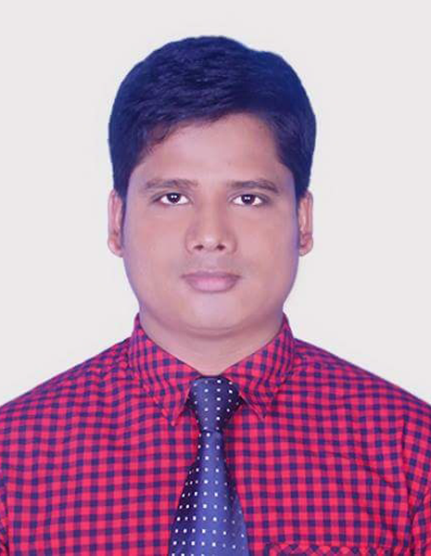
OF
Rasel Ahamed
Contact Address: Angar Para, Pulhat, Nilphamari.
Contact: 01750388428 / 01938530218
E-mail: raselahamed061991@gmail.com

Career Objective:
To Enter into a suitable position and work in an extremely demanding environment with the ultimate objective of career development opportunity where I can prove my skill and knowledge that creates maximum value for my organization.
Experience:
One (01) Year
01.05.2017 To 03.06.2018.
Dealer Acquisition Officer
Ceat AK Khan Ltd.
Bangla Bazar Dhaka,
And
Six (6) Months
01.07.2018 to 02.02.2019

Customer Relation Officer
Partex Star Group.
Star Furniture.
Tejgawon, Dhaka.
Academic Credentials:

Bachelor of Arts
Institution | : | Nilphamari govt college
Department | : | Degree(Pass)
Duration | : | 3 Years
Result | : | Completed
Year of Passing | : | 2012

Higher Secondary Certificate (H.S.C)

Institution | : | Pakerhat Science & Technical College
Group | : | Computer Science
Result | : | 4.31 (on a scale of 5.00)
Board | : | Technical
Year of Passing | : | 2009

Secondary School Certificate (S.S.C)
Institution | : | Kundopukur High School
Group | : | Humanities
Result | : | 2.06 (on a scale of 5.00)
Board | : | Rajshahi
Year of Passing | : | 2007

Computer Skills:

- Microsoft office ,(English & Bengali both front )
- Excel,
- Power Point,
- Internet and E-mail.
- Six Month Computer Training From BCE, Nilphamari.
Language & Communication Efficiency:

Good command over Reading, Writing, Listening and speaking in both
- English
- Bengali
Strengths:

- Ability to work hard.
- Excellent interpersonal communication.
- Quality and prompt decision making ability.
- Ability to build group and control.
- Strong motivating and commitment for work.
- Ability to manage and organize seminar and programs efficiently.

Presentation:
- Comfortable in presentation incorporating in depth business analysis.
Personal Information:
Name | : | Rasel Ahamed
Father’s Name | : | Md. Bazlur Rashid
Mother’s Name | : | Mst.Fatema Begum
Date of Birth | : | 18th June 1991
Present Address | : | Angar Para, Pulhat, Nilphamari.
Permanent Address | : | Angar Para, Pulhat, Nilphamari.
Contact | : | 01750388428
Sex | : | Male
Marital Status | : | Single
Height | : | 5.6 Inch
Religion | : | Islam
Nationality | : | Bangladeshi (By Birth)
National ID Card No | : | 19917316450000153
Blood | : | O+
Health Habit | : | Laborious

References:
Md. Mostafizur Rahman  Officer Incharge  Domar Thana, Domar, Nilphamari  Moba: 01711-828938  Relation: Familar | Md. Rashed Mahbub Rabban  Vice-President & HOB  Rangpur Branch  Moba: 01787-693893  Relation: Familar

Certification:
I,the undersigned certify that, this Curriculum Vitae correctly describes my qualifications and myself. Any willing mistake will result me in disqualification.

Signature

.......................................
(Rasel Ahamed)
Date:

