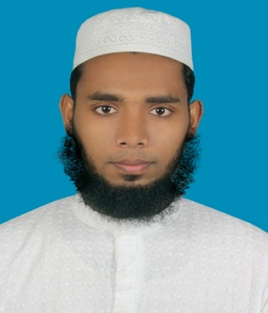
Resume of
Md. Shahinuzzaman

Career Objectives: To make a position in a corporate world where tasks are challenging, changing, constructive, innovative, needs high degree of motivating power and go for the ultimate betterment of the society.
Scholastic Records:
Study Level | Major | Institution | Year of  Passing | GPA  Scale | CGPA
BBA | Finance and Banking | Patuakhali Science and Technology University | 2013 | 4 | 3.26
H.S.C | Business Studies | Khulna Public College | 2007 | 5 | 4.80
S.S.C | Business Studies | Sreekala Secondary High School | 2005 | 5 | 4.38

Computer Literacy:
- MS office (word, access, excel, power point), SPSS and DEA.
- Knowledge on internet and computer hardware.
- Ability to work with several operating systems, including Windows XP, Windows 7, Vista.
Language Proficiency:
- Bengali (Reading, Writing, Listening, Speaking)
- English (Reading, Writing, Listening, Speaking)
- Urdu (Listening, Speaking)
- Arabic (Reading)

Hobbies:
- Reading, Travelling, Playing indoor-games and Cricket.

Reports and Research Experiences:
- Determinants of Equity Prices in the Stock Markets of Bangladesh.
- The impact of financial structure on profitability: Study of Bangladesh’s Textile Sector.
- Bank’s performance and efficiency analysis (using DEA).
- A Comparative Profitability and Operating of State Owned General Insurance and Private Owned General Insurance in Bangladesh.
- Impact of Macroeconomic Variable on Stock Market Liquidity in Bangladesh.

Internship:
- “Role of Credit Rating in the Banking Sector after Introduction of Basel II Regulation” – A Review on Bangladesh Context; (1st January, 2013 to 31st March, 2013 at WASO Credit Rating (BD) Ltd.: Haque Chamber (Level-5 & 6), 89/2, West Panthapath, Dhaka-1215, Bangladesh.)

Strengths:
- Leading capacity;
- Disciplined approach to work in team;
- Creative and innovative;
- Capability of work under pressure;
- Ethical and responsible to work;

Personal details:
- Name : Md. Shahinuzzaman
- Parents name : Md. Abu Bakar Siddique, Nilufa Yesmin
- Date of birth : October 10, 1988
- Blood Group : A⁺(Positive)
- Nationality : Bangladeshi
- Marital status : Unmarried
- Permanent & Contact Address:
C/o: Md. Abu Bakar Siddique
Vill: North Sreepur, Post: South Sreepur,
Upazila: Kaliganj, District: Satkhira,
Bangladesh
- Mobile : +88 01719261895/+88 01916611414
- E-mail : shahinbba06@yahoo.com

References:
Professor Badiuzzaman
Dean
Faculty of Business Administration and Management
Patuakhali Science and Technology University
Email: bzaman_pstu@yahoo.com
Cell: +88 01716287109
Sk. Md. Lutful Kabir
Deputy Director
Securities and Exchange Commission
Email: lfkabir@yahoo.com
Cell: +88 01712556786

I do hereby declare that all information here is true of my knowledge and I’ve no criminal records in any civil court or police station. If required and where applicable, this document can be supported by appropriate authentic certificates/Papers.


....................................
Md. Shahinuzzaman Date: 03.11.2013

