Curriculum Vitae  Sourov Das Shuvo  February 6, 1995.  Bagbari, Sylhet.  shovoc55@gmail.com  +8801738042784 | 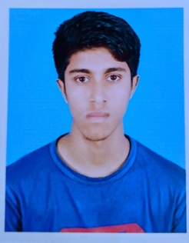

OBJECTIVES:

To work in a growing organization where I can get the opportunities to prove my abilities and strength by accepting challenges, fulfilling the organization goal and climb the career ladder through continuous learning and commitment.

ACADEMIC QUALIFICATION:

Examination | Board/University | Group/Subject | Result | Passing Year
B.Sc(Hons) | Leading University, Sylhet | Computer Science & Engineering | 3.46 (out of 4) | 2019
H.S.C | Sylhet | Science | 4.40(out of 5) | 2013
S.S.C | Sylhet | Science | 4.75 (out of 5) | 2011

LANGUAGE APTITUDE SKILL:

- English: Good both spoken and written command.
- Bangla : Mother Tongue

COMPUTER LITERACY:
- Software Engineering( Laravel, Java Swing, Android)
- Microsoft office applications
- Adobe Photoshop
- Operating system
- Internet browsing literacy

INTER PERSONAL SKILL:

- Having the potency to work under pressure and proper management ability.
- Well discipline, self-motivated, enthusiastic, helpful and diligent.
- Ability to handle any situation.

PERSONAL DETAILS:

Father’s Name : Samar Das
Mother’s Name : Radhika Rani Deb
Religion : Hindu
Marital Status : Single
Permanent Address : Bagbari, Sylhet
Nationality : Bangladeshi
National ID : 825 549 5346

CO-CURRICULAR ACTIVITIES:

Participant
LU Idea Hack 2018, A hackathon Program

Ex Member
Leading University Computer Club(LUCC)
Leading University Social Service Club(LUSSC)
Leading University Photographic Society(LUPS)
Leading University Cycling Society(LUCS)

Ex Vice President
Leading University Photographic Society (LUPS)

REFERENCES:

Rumel M S Pir
Head
Department of EEE
Leading University, Sylhet
Email : rumelpir@gmail.com
Contact No : +8801758-228736

CERTIFICATION:

I, the undersigned, certify that to the best of my knowledge and belief, this resume correctly describes my qualifications and me. I understand any willful misstatement described here may lead to my disqualification.


Sourov Das Shuvo Date: 20 February, 2019

