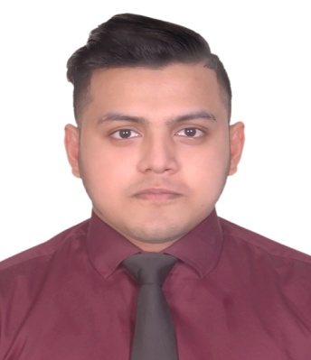Syed Muhit- Ur Rahman
Address: 39/12, East Hajipara Bou Bazar, East Rampura Dhaka-1219
Mobile: 01723772221
Email: muhit13@gmail.com

CAREER OBJECTIVE

Aspire to build a long term career in the Marketing and International Business sector with opportunities for career growth and to use my skills in the best possible way for achieving the organization goals.

EDUCATIONAL QUALIFICATION

Bachelor of Business Administration (BBA) in Department of Marketing and International Business (2014-2019)
North South University
Major:
International Business
CGPA: 3.33 in a scale of 4.00 (88%)

Higher Secondary Certificate (H.S.C) 2009-2011
Government Science College
Group - Science
G.P.A – 3.90 in a scale of 5.00
Secondary School Certificate (S.S.C) 2009
Government Science College and Attached High School
Group – Science
G.P.A – 5.00 in a scale of 5.00

OTHER SKILLS & INTEREST

Languages – Bengali – Native fluency
English – Professional fluency
IELTS SCORE- 6.5 Overall no band less than 6
Good Communication skills
Microsoft PowerPoint
Martial Arts (Shaolin Kung fu – Brown belt)
Travelling
Movies
Music

PROJECT & COURSE WORK

Course: Organizational behavior, Spring ‘18
Project: Managers roles and activities in an institution
Description: Visited a financial institution and bank to interview of a manager about his managerial skills, leadership qualities, Employee management etc.
Role: Interviewer and presenter.
Course: Entrepreneurship, summer’18
Attended a seminar on entrepreneurship and how the virtual reality headset works and experience it.

INTERNSHIP: STAR DELTA ENGINEERS LTD.
Department: Operations Management

Internship period: 5th February to 5th of May 2019

