Curriculum Vitae of
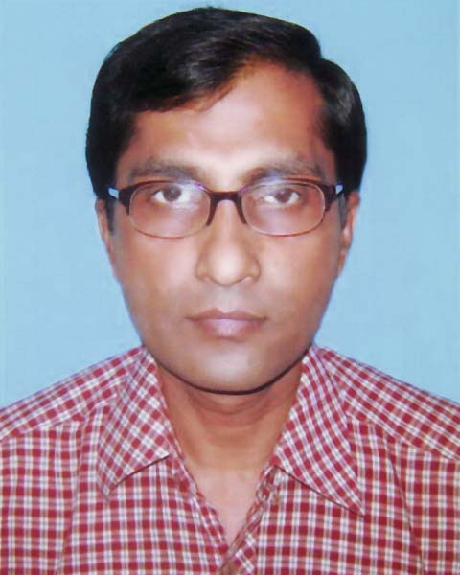
MD. TOFAZZAL HOSSAIN (Zakir)

MAILING ADDRESS:
81, West Kafrul, Sher-e-Bangla Nagar
Agargaon, Taltola, Dhaka-1207.
Contact Cell # 01747-910149
E-mail: zhcomputer786@gmail.com

PERSONAL INFORMATION

Name : MD. TOFAZZAL HOSSAIN (Zakir)
Father's Name : Late Md. Mozibur Rahman
Mother's Name : Mrs. Gulesan Begum
Present : 81, West Kafrul, Sher-e-Bangla Nagar
Agargaon, Taltola, Dhaka-1207.
Permanent : Village : Borshivanga, Post Office : Borshivanga
Thana : Kazipur, District : Sirajgonj
Contact Number : 01747-910149
Date of Birth : February 12, 1967
Marital Status : Married with two child
Religion : Islam
Nationality : Bangladeshi by birth

COMPUTER SKILLS

MS OFFICE (MS Word, MS Excel, MS Access, MS PowerPoint)
Adobe Photoshop
Adobe Illustrator
E-mail & Internet browsing.

TYPING SKILLS

50 Word per minute in English
40 Word per minute in Bengali (Using Munir Keyboard)

JOB EXPERIENCE

About 15 years job experience in different private organization which is described below:

A) Name of Company  Period  Position  Division | : The ACME Laboratories Ltd. (Largest Pharmaceutical Company in Bangladesh)  : January, 1999 to June 2013.  : Administrative Officer  : Administration & Human Resources Division
JOB RESPONSIBILITY:
To ensure the effective execution of day to day leave management and forwarding monthly report regarding leave status.
To facilitate & prepare all type of documents and formats and day to day administrative & HR related work.
To facilitate & prepare employee job description & job specification as per the direction of HR Manager.
To assist HR Manager in recruitment and selection process such as CV short listing as per the set criteria, interview score sheet preparation, prepare appointment letters, record keepings of the employees.
To maintain appointment letter for new appointed employee & their personal files, different types of preserving various HR related documents, data and records.
To design, prepare & maintain of all ID cards for the ACME Group.
Computer composing of Director's and Admin related Emergency & Large volume of work.

B) Name of Company  Period  Position  Division | : SABA Publications (A sister concern of Shamoly Ideal Polytechnic Institute)  : June, 2014 to March, 12016  : Administrative Officer (Computer Operator)  : Administration Division
JOB RESPONSIBILITY:
All kinds of technical text books composing, cover page design, book formatting, getup-setup etc.
Employee’s personal file and record keeping.
Employee’s daily attendance record.
To assist HR Manager in recruitment and selection process such as CV short listing as per the set criteria, interview score sheet preparation, prepare appointment letters, record keepings of the employees.
To design, prepare & maintain of all employee’s ID cards.
Computer composing of Director's and Admin related Emergency & Large volume of work.

C) Name of Company  Period  Position | : New SAS Rent-A-Car (Vehicle rental company)  : May, 2016 to till date  : Executive (Admin & Finance)
JOB RESPONSIBILITY:
All kinds of Official file maintain, internet browsing, computer related documentation
Employee’s personal file and record keeping.
Employee’s daily attendance record.
To facilitate & prepare all type of documents and formats and day to day admin related work.
Computer composing of Proprietor's and Admin related Emergency & Large volume of work.

EDUCATIONAL QUALIFICATION

Examination  Board & Year  Division | : Secondary School Certificate (SSC)  : Rajshahi Board, 1983  : First Division
Examination  Board & Year  Division | : Higher Secondary Certificate (HSC)  : Rajshahi Board, 1985  : Second Division


__________
SIGNATURE

