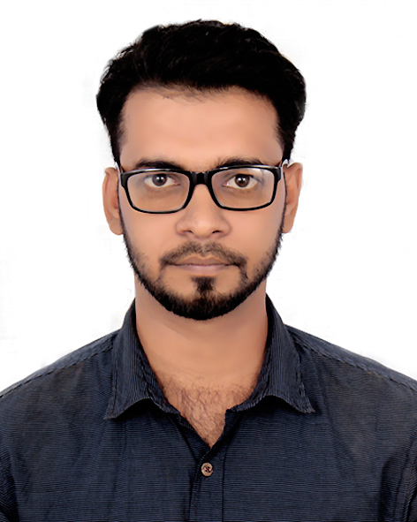
RESUME
OF
RASEL AHMED

Location:House No#7,Block#F, P.O:Education Board,
P.S: Jessore Sadar, District:Jessore.
Mobile No 1:+88 01674967802
Mobile No 2 :+88 01913335641
E-mail: ahmedrasel725@gmail.com

Career Objective:

Buildup a challenging & rewarding career in an organization that provides structured career advancement within the extent of competitive & dynamic service environment and challenging opportunities with sincerity, punctuality, competency and hard work.

Employment History:

Total Year of Experience: 6 Month(s)

- Accounts Officer under BACI-SEIP Project (October 01,2018 to Continue)

HTN Institute of Science and Technology (HIST)
Location:Jashore-Magura Road, Bahadurpur, Jashore.

Duties/Responsibilities:
- Look after all banking matter.
- Budget preparation & planing as well its implemantation & monitoring.
- Analytical review on montly financial result.
- Supervision in the management of fixed asset and inventory record.
- Corporate & secretarial work.
- Conduct board & its committee meeting and preparation of circulation of meeting minutes and ensure the compliance of resulation passed in said meeting.

Academic Qualification:

Exam Title | Subject | Institute | Result | Pas.Year | Duration
MBA | Accounting | Dhaka College | CGPA-3.16 out of 4.00 | 2015 | 1 Year
BBA | Accounting | Dhaka College | CGPA-3.06out of 4.00 | 2014 | 4 Years
HSC | Business Studies | Jashore Cantonment College | GPA-4.90 Out of 5.00 | 2009
SSC | Business Studies | Jashore Zilla School | GPA-4.81 Out of 5.00 | 2007

Training Summary:

Training Title | Tropic | Institute | Location | Year | Duration
Training on Organisational Management and ERP System | Tally Software | CCDB Hope Foundation | Boroipara,Savar,Dhaka 1340 | 2019 | 4 Days
Computer Office Application. | MS-Word, MS-Excel, MS-Access, MS-Power Point & Internet Browsing. | Imperial Institute Of Technology(IIT) | Jashore | 2015 | 6 Month

Computer Literacy:

*** Computer Office Application Program MS-Word, MS-Excel, MS-Access, MS-Power Point (2007, 2010, 2013, 2016) & Internet Browsing.

*** Operating System: Windows-XP, Windows-7, Windows-8, Windows-8.1, Windows-10 Computer Servicing and Software Installation, Modem etc.

Language Proficiency:

Language | Reading | Writing | Speaking
Bengal | High | High | High
English | High | High | Medium

Personal Information:
- Name : Rasel Ahmed
- Father`s Name : Alauddin Ahmed
- Mother`s Name : Rashida Begum
- Date of Birth : 12 January,1991
- Home District : Jashore
- Nationality : Bangladeshi (By Birth)
- Marital Status : Married
- Gender : Male
- Religion : Islam
- ID NO : 5065523846
- Contact Number : +88 01913335641
- Height : 5` Feet 6`` Inc
- Blood group : B+
- Present Address :House No#7,Block#F, P.O:Education Board, P.S:Jashore Sadar, District: Jashore.
- Permanent Address : House No#7,Block#F, P.O: Education Board ,P.S: Jashore Sadar, District: Jashore.
Reference Information:
Reference 1 |  | Reference 2
Name | Engr.Babul Aktar | Name | Md.Monzurul Hasan
Designation | Focal Person(SEIP-BACI)Project | Designation | SR Executive HR & Admin
Organization | Help The Needy Charitable Trust.  43/3 Monico Mina Tower Apartment E-7,West Agargaon  Sher-e-Bangla nagar,Dhaka-1216. | Organization | FRESCO EME LTD.  Road#5,House#70/1,Banani DOHS,Dhaka
Contact Number | 01712-080178 | Contact Number | 01785-854484
Email | carebabul@gmail.com | Email | Monzurulhasan123@gmail.com

Icertify that all information stared in this resume is true and complete to the best of my knowledge. I authorize the respective authority to verify the information provided on this resume.


Signature:

