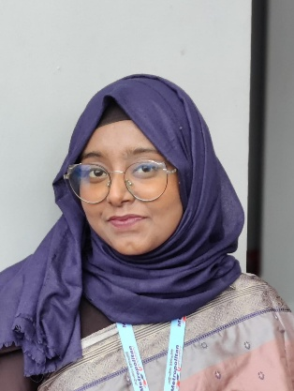
curriculum Vitae

Chowdhury Nuzhat Tabassum

House no: 31, Block- E, Road 2
Shahajalal Uposhohor
Sylhet sadar
Mobile no. 01742105512
Email: nuzhattabassum484@gmail.com

Profile : Looking for a job opportunity where I can use my education and skills to achieve personal and professional growth while making a positive impact on the company.

Educational Qualification

Bachelor of Arts
Subject : English Literature and History
Session : 2023- 2024
University : Metropolitan University, Sylhet
Result : Running ( Thesis)

Higher Secondary Certificate (H.S.C)
College : Jalalabad Cantonment Public School and College, Sylhet
Group : Humanities
Result : GPA 4.58 out of 5

Secondary School Certificate (S.S.C)
School : Govt. Agragami Girls High School and College, Sylhet
Group : Science
Result : GPA 4.32 out of 5

Technical Expertise :
- MS Office ( Power Point, Word File, Excel)
- Internet Browsing, Email

Special Skills :
Communication, problem solving, Stress toleration, leadership, Creative Thinking, Team work.

Language : English, Bangla,Hindi

Extra Curriculum Activities

Former Joint Secretary
Flames Musical Club
Metropolitan University

About FMC : It’s a renowned musical club of Metropolitan University. Flames Music club focuses on cultivation of musical talent around the university campus. Students get to participate and exposed to various musical programmes, concerts througout the academic years.

Executive Member
Metropolitan Social Club
Metropolitan University

Personal Information
Father’s Name : Md. Etrat Hussain Chowdhury
(Advocate, Sylhet Judge Court)
Mother’s Name : Ismat Ara Begum
Headmistress ( Retired)
Turukkhola Govt. Primary School, sylhet
Date of Birth : 31.01.2001
Nationality : Bangladeshi
Blood Group : O negative
Marital Status : Single
Gender : Female

