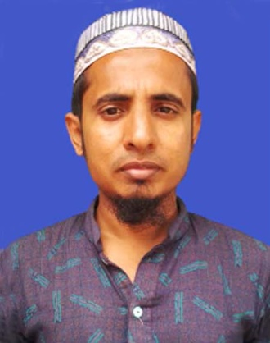
CURRICULAM VITEA
OF
MIZAN

Address:Vill-Paikpara,P.O-Banglabazar,
P.S-Dowarabazar,Dist-Sunamgonj
Mobile:01776504962

I was interested work in a dynamic,Challenging, creative and service oriented organization where I can explore my creativity and use my academic and working knowledge expertise properly.

Career Objective:
Build up my career.
Career summary:
Build up a challenging and rewarding career in an organization the provides structured career advancement with in extend of competitive and dynamic environment and face challenging oppurtunities sincerity, punctuality , commitment, self-competency and hard work.
Academic Qualification:
Exam Title | Concentration | Institute | Result | Pass Year | achievement
S.S.C | Science | M.D.P Model High School | GPA-4.31 | 2008 | Pass
H.S.C | Business Management | Dhaka Management College | GPA-5.00 | 2012 | Pass
Hon’s | B.ed(Hon’s) | Uttara University | GPA-3.53

Personal Profile:
Fathers Name : Assraf
Mothers name : Angura Begum
Permanent Address : Vill# Paikpara,P.O#Banglabazar
P.S#Dwarabaraz,Dist# Sunamganj
Present Address : Vill# Paikpara,P.O#Banglabazar
P.S#Dwarabaraz,Dist# Sunamganj.
Date of Birth : 15/09/1993
Marital Status : Maried
Relageon : Islam
Nationality : Bangladeshi
Hight : 5.00Ft
Job Experience : 1.I was working at Uttara Crescent Hospital,7
July 2010 from 15 Augst 2019.
2. I was working at Anowara mannaf girls
College as a Computer Operator, 1 January
2013 From 30 September 2014.
3. Now , I am Working at Prescription Point
Ltd,16 January till Now.
3. Computer Experience,Ms.Word,Ms.Excel,
Ms.Power Point etc.
Skill Experience 4. Computer Office Program- Ms Word,Ms
Excel,Ms Power Point etc.

Date: Signature:

