RESUME
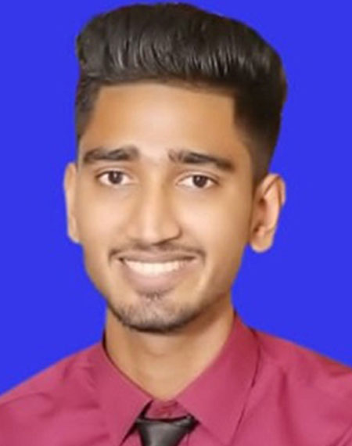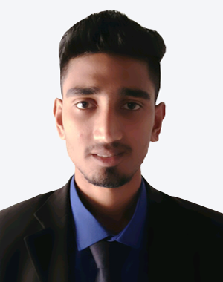

Photo
OF
RAYHAN AHMED CHOWDHURY
Mobile: 01728-106687
Email: tareqchy95@gmail.com

Career Objective

I am willing to work in a challenging environment and rewarding position, where dignity of work provides job satisfaction and the place of work provides Potential Avenue for learning and growing and to achieve top level in the hierarchy of the organization.

Educational Qualification

- B.Sc (Degree Pass)
            - Institution : MC College.
            - CGPA : 2.70 (out of 4.00)
            - Year of Passing : 2018
            - Session : 2013-2014
            - University : National University.
- Higher Secondary Certificate (HSC)
            - Institution : Jalalabad College.
            - Group : Science
            - GPA : 3.70 (Out of 5.00)
            - Grade :A-
            - Year of Passing : 2013
            - Board : Sylhet
- Secondary School Certificate (SSC)
            - Institution : Burunga Iqbal Ahmed High School And
College.
            - Group : Science
            - GPA : 3.94 (Out of 5.00)
            - Grade : A-
            - Year of Passing : 2011
            - Board : Sylhet

Computer Skill:

- Microsoft Word.
- Microsoft Excel.
- Microsoft Access.
- Microsoft Power Point.
- Internet & E-mail (BCC).
Experience:
- I am former employee (TM) at KFC & PIZZA HUT .
- M/s Ali And Sonce at Cash Counter (6 month).

Language Proficiency:

- Good Communication Abilities in Bengali.
- English (Fluent In Reading, Writing And Acceptable In Speaking).
- IELTS Score 5 (Overall).

Personal Information
- Name : Rayhan Ahmed Chowdhury
- Father’s Name : Late Sajjadur Rahman Chowdury
- Mother’s Name : Mrs. Mahbuba Begum Chowdury
- Present Address : Mohini-80, Lamapara, Sibgonj, Sylhet
- Permanent Address : Vill: West Tila para, P.O: Muktarpur,
P.S: Osmaninagar, Sylhet
- Date of Birth : 13/03/1996
- Marital Status : Unmarried
- Religion : Islam
- Nationality : Bangladeshi (By birth)
- Gender : Male
- Mobile Number : 01728-106687

About me:

I have tried to be an honest man. If get good and honorable job heartily I will try my best. I am very quick learned and able to develop new areas of expertise. I am highly motivated, organized and able to work under pressure as team leader.

Hobbes and fields:

Traveling and reading book, computer networking.

Declaration:

I Declare that all the information includes here are true to my knowledge. It required and where applicable, this document can be supported by appropriate authentic certificates.

Reference

Abdul Qaium Chowdhury
CID Inspector
01711-485548

Date: …………………………
(Rayhan Ahmed Chowdhury)

