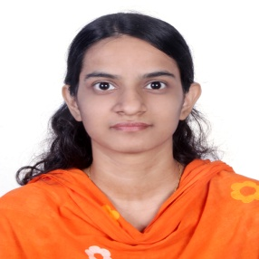

CV of
TANJILA KARIM CHOWDHURY
Arnob 44, Mirer Moydan, Sylhet.
Call: 01730251885
E-mail: chytanjila@gmail.com
C a r e e r O b j e c t i v e:

- To build a career that encounter challenge and creativity.
- Being professional administrator and wish to work in corporate level.
- Being a profession team worker to enrich the decision-making ability.
- To build my life in the light of honesty, dynamism and to develop both. Psychological and organizational position.

A c a d e m i c Q u a l i f i c a t i o n:

B.SC (Engg.)

Name of Institution | : | Metropolitan University ,Sylhet
Subject | : | Computer Science & Engineering
Result | : | 3.26
Passing Year | : | 2016

Higher Secondary Certificate Examination (H.S.C)

Name of College | : | Madan Mohan college
Name of Board | : | Sylhet.
Group | : | Science
Passing Year | : | 2011
Result | : | GPA- 3.10

Secondary School Certificate Examination (S.S.C)

Name of School | : | Fariza Khatun Girl’s High School
Name of Board | : | Sylhet
Group | : | Science
Passing Year | : | 2009
Result | : | GPA-4.38
.
Extracurricular Activities:

- Participated and presented project “Shuru theke Sheka” in the software section of the project exhibition held on 19th-20th September 2015 at Metropolitan University It Festival organized by the School of Science and Technology .
- Microcontroller & Robotics course

L a n g u a g e P r o f i c i e n c y:

Bangla: Proficient in writing, reading, listening and speaking.
English: Competent in writing, reading, listening and speaking.

Self Evaluation
- Ability to cope with different situation.
- Very good temperament and like to take challenge.
- Co-operative and innovative.
- Willingness to work in team.
- Organizing and leadership competence.
- Ability to interact with subordinate work force.

P e r s o n a l I n f o r m a t i o n

Name | : | Tanjila Karim Chowdhury
Father’s Name | : | Md. Anwarul Karim Chowdhury
Mother’s Name | : | Abeda Chowdhury
Permanent Address | : | Vill: Karimpur, PO & PS: Fenchuganj, Sylhet.
Date of Birth | : | 11th Feb 1993
Marital Status | : | Unmarried
Sex | : | Female
Height | : | 5′ 3″
Hobby | : | Internet Browsing, Traveling & Reciting Holy Quran
Nationality | : | Bangladeshi
Religion | : | Islam
Current Location | : | Arnob 44, Mirer Moydan, Sylhet.

R e f e r e n c e:

1. Chowdhury M.Mukammel Wahid | 2. Md.Mahfujul Hasan
Associate Professor & Head | Associate Professor
Department of CSE | Department of CSE
Mob : 01713328332 | Mob : 01620431610

