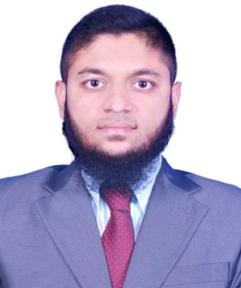
Curriculum Vitae

Name: Md Abdullah Afif
Word no : 09, vill: Bamonpara, City+post+Thana: Bheramara (7040)
District: Kushtia, Division: Khulna, Country: Bangladesh.
Contact Number :+88 01914066104,+8801750993689
Email : Mdafif901@gmail.com

Career Objectives :
I want to live my life of honesty and want to work in any Computer or Technical works. Although i have not any big academic Certificate, but i have some good Knowledge and initiatives for any kind of works, So i believe to ALLAH, that I shall be successful with my honesty.

Works Experience :
- I worked at Bangladesh Army as a soldier and office assistant .
- I was Cadet Adjutant in a B.N.C.C. annual training course .
- I am leading business of my father for last 3 years .
- I work online with the following work : (a) passport processing , ( b) Visa processing, (c) Foreign Doctor appointment, (d) Air ticket confirm, (e) Email , (f) Etc .
- I drive my personal car and motorcycle with safety .
- Computer work : (a) MS Word, (b) MS Excel, (c) MS Power point, (d) Software and internet data entry, (e) Internet browsing and Communication, (f) Adobe Photoshop 7.0, (g) Software install .
- Monitoring and find out better working rules for success.
Education Qualifications :
Exam Title | Subject | Board | Result | Year
S.S.C | Vocational(GM) | Bangladesh Technical Education Board | 4.09 | 2009
H.S.C | Arts | Bangladesh Open University | 2.95 | 2014

Technical Skills :
Office Management | MS Word, MS Excel, MS Power point
Operating System | Windows XP/07/10
Others | Software and internet data entry , Software install , Multimedia, Internet browsing and Communication, online document and visa processing, Adobe Photoshop 7.0 etc.
Driving | Motorcycle and Light Vehicles .
Mechanics | Welding , Drilling, Grinding, Etc .
Admin job | I can understands any work for monitoring and find out better working rules for success.

Extra Qualifications :
Ser / No | Name of Course | Result
3 | Special Office assistant basic course | Complete
1 | B.N.C.C | Complete
2 | Army Basic Training | Complete

Language Proficiency :
Language | Reading | Writing | Speaking | Typing
Bangle | High | High | High | High
English | Medium | Medium | Medium | High
Urdu | Low | Low | High | Nil
Hindi | Nil | Nil | High | Nil

Habits :
- Thinking some beater policy for any Works and Good Leadership.
- Find out the true knowledge of any topic.
- Honest life and Learning about Religion.
- Help to others for any good works.
- Solve any problem with personal tactics through self confidence and flow the better policy.
- Good communication habit and Helpful mind.
Some personal words :
I am Md Abdullah Afif . I was a good Soldier office assistant in Bangladesh Army, but after 5 years i took retirement, Because i was attacked by Br Asthma . But now I am so much better . After some month of retirement i lead a business with success . But i stop the business for some personal reasons . And now i want to do a good job for better life and future.
Interest :
- Internet browsing and acquiring new knowledge .
- Help others to do good work .
- Read religious books and get the right knowledge .
- Good leadership of any success works.
- Traveling and Friendships.
- Driving.
- Any work audits.
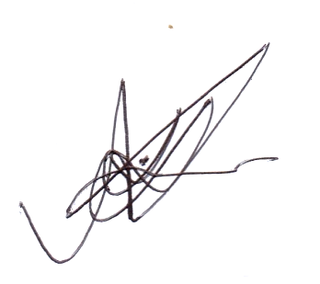
- Develop Social humanity
- Try to find and apply the best way for every work. Etc .

Md Abdullah Afif

