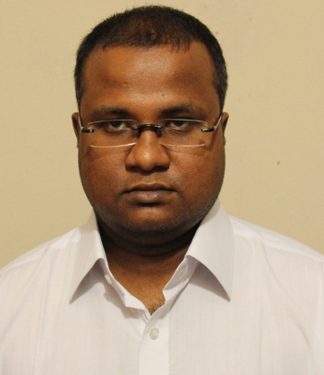
Curriculum vitae of
Md. Ashikur Rahman

CONTACT ADDRESSES:
Email: ashikur00@gmail.com
Cell phone: 01682390132
Mail: Mail: 89/4,Ground floor, Hatembug mosque, Dhanmondi, road-8A
Dhaka-1209 .
Permanent address: Parijat R/A,House#32,Road #02,Rajshahi.

CAREER OBJECTIVES:
To be a successful professional in electrical engineering, seeking for a challenging position in a competitive and growth oriented environment where my skills and knowledge along with my enthusiasm can be utilized.

PERSONAL INFORMATION:
Name: Md. Ashikur Rahman
Father’s name: Md. Anisur Rahman
Mother’s name: Nazmun Nahar Anis
Date of birth: 1st January, 1991
Gender: Male
Religion: Islam (Sunni)
Marital status: Single
Nationality: Bangladeshi (by birth)
EDUCATIONAL QUALIFICATION:
Name of the Examination | Group/ Department | GPA | Institution/ University | Passing Year
B.Sc | Electrical & Electronic Engineering  (EEE) | 3.32 (Out of 4) | United International University | 2013
HSC | Science | 4.10 (Out of 5) | Varendra College, Rajshahi | 2007
SSC | Science | 4.13 (Out of 5) | Seroil Govt.High school | 2005

THESIS - PROJECT TOPIC:
An AC motor protection by using PLC.

LANGUAGE PROFICIENCY:
Fluent in Bengali and English

COMPUTER SKILLS:
OS: Windows XP, Vista, Seven
Office application: MS Word, MS PowerPoint
Programming language: C.
Engineering Software: PSpice, Electronic Workbench, Proteus, Visual studio, Lab-view,
Cisco Packet Tracer, MATLAB, Or cad, etc.

REFERENCES:
- Mrs. Helena Bulbul
Senior Lecturer, EEE,UIU
Email: helena@eee.uiu.ac.bd
Mobile: 01971 733481

- Mr. Iqbal Bahar Chowdhury
Associate Professor, EEE, UIU
Email: ibchy@eee.uiu.ac.bd
Mobile: 01711 437332

DECLARATION:
I hereby declare that all the information given in this CV is complete and accurate to the best of my knowledge.

Md. Ashikur Rahman

