Curriculum Vitae

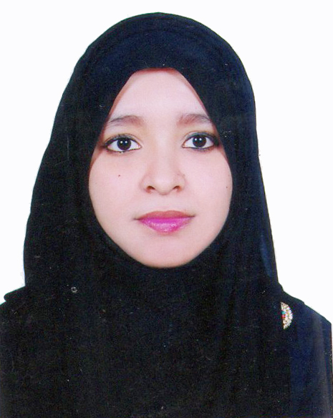

Of
Farhana Parvin
Contact Address:

Sebok- 68, Raynagar
Mirabazar, Sylhet- 3100.
Cell: +8801704406761
Email: farhana.bba31@gmail.com

Objective
Objective Career

To obtain a responsible position through which I can utilize my knowledge, enhance my skills as well as can acquire the ability to face a high level of challenges, and get myself provided with varied experience and at the same time I would like to contribute by best to the organization.

Educational Qualifications

Master of Business Administration (MBA):

Institution : Metropolitan University, Sylhet.
Session : 2018-2019
Major : Finance & Banking
Result : CGPA- 3.45 (Upto 2nd Semester- Out of 4.00 on scale)

Bachelor of Business Administration (BBA):

Institution : Metropolitan University, Sylhet.
Session : 2013-2017
Passing Year : 2017
Major : Finance & Banking
Result : CGPA- 3.56 (Out of 4.00 on scale)

Higher Secondary Certificate (H.S.C):

Group : Business Studies
Passing Year : 2013
Result : GPA- 4.30 (Out of 5.00 on scale)
Institution : SAARC International College Bangladesh, Sylhet.
Board : Sylhet.

Secondary School Certificate (S.S.C):

Group : Humanities
Passing Year : 2011
Result : GPA- 3.56 (Out of 5.00 on scale)
Institution : Syed Hatim Ali High School, Sylhet.
Board : Sylhet.

Computer Knowledge

- Able to prepare any type of documents with MS word & Excel
- Able to prepare any type of slide with MS PowerPoint
- Having knowledge on Internet browsing and e-mail, corresponding.

Self Assessment

- Strong desires for leading an honest life with dignity.
- Aspiration to build a career showing superior performance.
- Energetic, Sincere, Hard working, honest and Dutiful.
- Able to work at any time at any place.

Language Proficiency

- Bengali: Good communication & presentation skills in Bengali as a native speaker
- English: Good communication & presentation skills in English as a second language.

Personal Details

Father’s Name : Kabir Uddin
Mother’s Name : Fateha Parvin
Date of Birth : 5th February, 1995
Permanent Address : Sebok-68, Raynagar
Mirabazar, Dist. Sylhet.
Present Address : As Above
Marital Status : Unmarried
Nationality : Bangladeshi (By Birth)
Gender : Female
Religion : Islam
Experience:

I had been successfully completed Internship in National Bank Ltd. at Shikdar Tower Branch, Sylhet for 3 months.

Reference :
1. Md. Mubin Ahmed
Senior Officer
Janata Bank Ltd.
Amberkhana Branch, Sylhet.
Cell: 01731777698
2. Mohammad Kamrul Ahsan
Assistant Professor
Department of Business Administration
Metropolitan University, Sylhet.
Cell: 01616404243

Proclamation:

Hereby, I declare that all information stated here is true to the best of my concern.



Farhana Parvin

Date:------------------------------------

