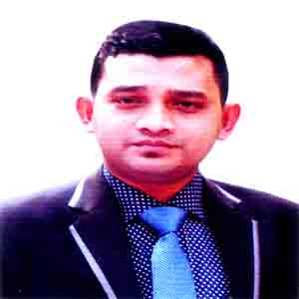
curriculum Vitae
Of
MD. HOSNA MUBARAK
Mobile: 01858-344179

Present Address

House-1038/4, 7up Goli, Mirpur-10,
Dhaka-1216.
Cell: 01858-344179
E-mail: hosnamubrakmist@gmail.com

Career Objective

To build a challenging career as devoted trustworthy as well as competent work in dynamic private sector that will provide a learned environment and encourage optimization of my abilities. I like to take the rewarding opportunities to tackle problems arising particularity in any sector to provide myself as dynamic personal.

Academic Achievement

Degree : Bachelor of Civil Engineering (BSC)
Institution : European University of Bangladesh.
Department : Civil Engineering (DH) Holder Going on.

Degree : Diploma in Civil Engineering
Institution : Bangladesh Sweden Polytechnic Institute,
Kaptai, Rangamati, Hill Tracks.
Department : Civil (Special Wood) Technology.
GPA : 2.80 (Out of Scale 4.00)
Passing Year : 2014
Board : BTEB, Dhaka.

Degree : Secondary School Certificate (Dhakil)
Institution : Amzadia Fazil Degree Madrasha, Chokaria.
Department : Science
GPA : 4.75 (Out of Scale 5.00)
Passing Year : 2010
Board : Madrasha

Computer Skills
- Microsoft Office : Ms Word, Ms Excel,
Ms PowerPoint, Browsing Internet.

Extra Training Summary
Name of Course & Training | Duration | Name of Training | Year | Result
Industrial Basic Training | 3 Months | Equity Property Management (pvt) Ltd. Chittagong. | 2014 | Certified
Basic Computer | 3 Months | Skill Development Training Center, Teknaf, Cox’s bazar | 2016 | Certified
Steel Fixture & Fabrication | 3 Months | Montage Training Center, Tongi, Gazipur. | 2017 | Certified
Mason | 1.5 Months | Skill Development (Sudokkha) Training Center, Dhaka. | 2017 | Certified
Spoken English | 3 Months | FM Mathod, Uttara Campus, Dhaka. | 2017 | Certified

Others Skills

Drawing | Plumbing | Electric | Suturing | Mason
Auto Cad 2D and 3D

Work Experience

- I worked Maq Engineering Ltd. as a Sub Assistant Engineer from 01st January 2015 to 31st August 2015.

- I worked Hazi Mohammad Shamsuddin Properties Ltd. as a Supervisor from 1st April 2016 to 31st November 2016.

- I worked MIST Polytechnic as a Junior Instructor of Civil Engineering & RS Department from 1st February 2017 to till now.

Personal Information

- Father’s Name : Md. Mofzol Ahmed
- Mother’s Name : Mst. Fatama Begum
- Present Address : House-1038/4, 7up Goli, Mirpur-10,
Dhaka-1216.
- Permanent Address : Vill- Nunachari, P.O- Kalarmarchara,
P.S- Moheshkhali, Dist- Cox’s-bazar.
- Date of Birth : 01st February 1994
- Nationality : Bangladeshi
- Place of Birth : Cox’s-bazar, Bangladesh
- Religion : Islam
- Marital Status : Unmarried
- Height : 5'-6''
- Sex : Male
- Weight : 62Kg.
- Blood Group : O+
- National ID No. : 19942214959000460

Language & Commutation Skill

- Excellent Speaking Reading and Writing in Bangla.
- Fairly fluent in speaking, reading, writing and listening in English.

Reference

- Md. Abdul Motin Hawlader
Chief Instructor of Civil Engineering Department.
Bangladesh Sweden Polytechnic, Kaptai.
Assistant Director of BTEB, Dhaka.
Mobile: 01727018285

- Md. Alauddin Al-Mamun
Vice Principal of Montage Training Certification of Bangladesh
142/143, Mirajpara, Tongi, Gazipur.
Mobile: 01914841046

Interesting

Leisure interest Including –Reading books, traveling, watching TV, browsing internet, participating several workshops, participating games and social activities.

Deceleration

I hear by declared that the information given above by me is correct, complete and convict to the best of my knowledge and belief. I certify that my willful miss-statement described here in lead to my disqualification or dismissal if employed.

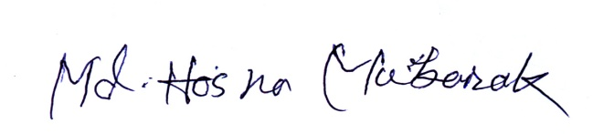
Sincerely Yours,

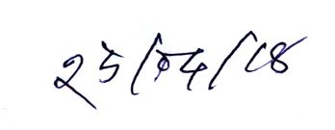
................................................
Date: Md. Hosna Mubarak

