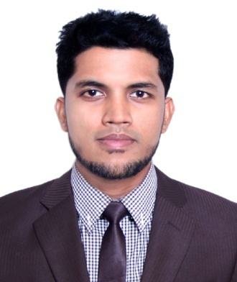
Resume of

Md.Ibrahim Bin Tanbir
Sottighar,Moglabazar, Sylhet
Cell: 01675-638328, 01717-311711
E-mail : Ibrahimbintanbir@gmail.com

Career objective

Rendering of conceptual and organizational skills along with creativity, dynamism, enthusiasm and thus making position in corporate world. Moreover, enhancing and developing individual skill through all out efforts as well.

Academic qualifications

Post- graduation | Master of Business Administration (MBA)  Passing Year: 2018  Major: Human Resource Management (HRM).  ID: 1721017112  CGPA: 3.23 on a 4.00-Point Scale  Institution: Leading University, Sylhet.
Graduation | Bachelor of Business Administration (BBA)  Passing Year: 2016  Major: Marketing  ID: 1201010238  CGPA: 2.66 on a 4.00-Point Scale  Institution: Leading University, Sylhet.
H.S.C. | Higher Secondary Certificate Examination  Passing Year- 2011  Group- Business Studies  Board- Sylhet  Result- GPA: 4.10 on a 5.00-Point Scale  Roll: 500421  Institution- Scholarshome,Sylhet
S.S.C. | Secondary School Certificate Examination  Passing Year- 2009  Group- Science  Board- Sylhet  Result- GPA: 4.63 on a 5.00-Point Scale  Roll: 100586  Institution- Shahjalal Jamia Islamia High school,sylhet.

Personal details
Name : Md. Ibrahim Bin Tanbir
Father’s Name : Late.Jaidul Islam
Mother’s Name : Razia Begum
Permanent Address : Village : Sottighar, P.O: Moglabazar,
P.S: Moglabazar, District: Sylhet
Present Address : Village : Sottighar, P.O.: Moglabazar,
P.S: Moglabazar, District: Sylhet
Date of Birth : 3 May 1993
Nationality : Bangladeshi
National ID no. :19939113160000397
Birth registration no. : 19939133160028732
Religion : Islam
Marital Status : Single
Blood Group : O (+ve)
Sex : Male
Height : 5 feet 7 inches

Language proficiency
- Bengali
- English
- Sylheti Dialect
Self-assessment
- Strong desire for leading an honest life with dignity.
- Hard working, sincere and eager to learn.
- Strong determination to attain goals.
- Strong analytical ability and communication skills.
- Comprehensive creative thinking and fast learning capacity.
- Efficient in teamwork and ready to accept challenges.
- Energetic and willing to take charges

Personality traits:
Proactive, religious, integrity, self-motivated, balanced, sincere, organizing, analytical, communicating effectively, positive & flexible, a good listener & follower etc.

Computer literacy
Office Applications- MS Word, MS Excel, Power Point, Web Browsing.

Interest in
- Participating in creative works.
- Participating in sports including cricket, football, carom etc.
3) Riding Motorbike, Watching movies, Traveling, Listening music.

References
Md. Asaduzzaman Khan  Assistant Professor  Head (Acting)  Department of Computer Science & Engineering  Leading University, Sylhet  Contact: 01711-003233  e-mail: head_cse@lus.ac.bd | Shamsu Uddin  Assistant Professor (Marketing)  Department of Business Administration  Leading University, Sylhet  Contact: 01195399384  e-mail: sushakib@yahoo.com

I, hereby, declare that the information given above is true, fair and fully updated.

Sincerely yours.

(Md. Ibrahim Bin Tanbir)

