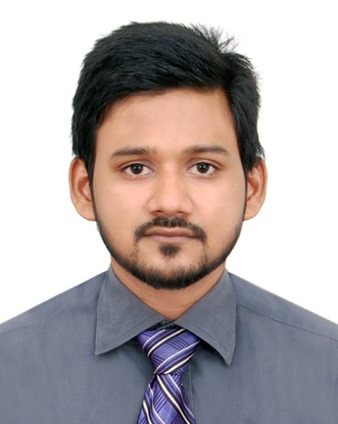
RESUME
OF
MD. SHAMSUJJAMAN
Address: Shamata-12,(Nehar Villa), Chalibondor, Sylhet 3100
Mobile: +8801729623296
E-mail:samboyjaman@gmail.com

CAREER OBJECTIVE

I strongly believe that if I get an opportunity in my life to show my effort then both company and I will be benefited. One of my dreams is to face any type of challenge in my career path to secure a position with a well-established organization.

WORKING EXPERIENCE

Serial No. | Company/Shop Name | Company/Shop Type | Name of the Post | Work Duration
01 | MediAid & MediCare Diagnostic Centre | Private Company | Computer Operator & Report Delivery | From 01-03-2015  To Present
02. | Bandhan Jono-kollyan Society | An NGO Institute | Office Assistant and Data Entry Operator | From 05-02-2013  To 21-12-2014
03. | Computer Garage (Computer Sales & Service Centre) | Private Shop | Computer Hardware & Troubleshooting Engineer and also worked as A Computer Operator | From 07-11-2010  To 30-12-2012

TRAINING SUMMARY

Serial No. | Training Title | Institute | Location | Year | Duration
01. | Spoken English &  Phonetics | Saifur’s | Jollarpar Road, Zindabazar, Sylhet. | 2008 | 3 Months
02. | Computer Office Application Programming | Bangladesh Computer Council | Block-E,  Road No: 4,  Upashahar, Sylhet. | 2012 | 3 Months

ACADEMIC QUALIFICATION

Exam Name | Concentration | Institution | Board/  University | Result/  Class | Passing Year | Duration
SSC | Humanities | Shahjalal Jamia Islamia School & College, Mirabazar, Sylhet | Sylhet Board | GPA: 3.31  (1st Class) | 2008 | 2 years
HSC | Business Studies | Sylhet Science College,  Manikpir Road, Sylhet | Sylhet Board | GPA: 3.60  (1st Class) | 2010 | 2 years
BSS (Honors) | Political Science | Madan Mohan College,  Lamabazar, Sylhet | National University | CGPA: 2.70  (Higher 2nd Class) | 2015 | 5 Years
MSS (Masters) | Political Science | MC College, Sylhet | National University | ------ | Appeared | 1 Year

COMPUTER SKILLS

Hardware : Fundamental Concept of Hardware.
Microsoft Office : Word, Excel, Access, Power Point.
Operating System : Windows XP, Windows 7, Windows 8, 8.1 & 10
Internet : Experienced in Internet, e-mail and Web Browsing.

INTERESTS & ACTIVITIES

- Social Working
- Traveling And Outing
- Riding Motor Bike
- Playing Cricket

PERSONAL INFORMATION

- Name : MD. Shamsujjaman
- Father’s Name : Late Abdus Salam Chy
- Mother’s Name : Layly Begum Reba
- Permanent Address : Shornoshikha-144, Block-A, Kodomtoli, Sylhet-3100
- Present Address : Shomota-12 (Nehar Villa), Chalibondor, Sylhet-3100
- Mobile : +8801729623296
- Date of Birth : 1st March 1992
- Religion : Islam
- Nationality : Bangladeshi (By Birth)
- Ethnicity : Bengali
- Sex : Male
- Marital Status : Single
- Blood Group : O+ (Positive)
- Height : 5’ 3”

REFERENCED BY
- Mr. Abu Toiyob Mohammad Abdullah
Joint Director,
Bangladesh Bank
Taltola Sylhet.
Mobile: 01688-112150

- Mrs. Asma Ul Husna
Head of the Department,
Political Science
Madan Mohan College, Sylhet.
Mobile: 017151-133944

DECLARARTION

I do hereby declare that the above statements are correct and completed to the best of my knowledge.

Yours Obediently,
Md. Shamsujjaman
Date: 07-01-2019

