CURRICULUM VITAE  Of  KHOKAN HALDER  MAILING ADDRESS:  Flat no. : 6/2.  369, Ekota,  Madina Market, Sylhet.  Contact Number: +88 01746727989.  e-mail:khokanhalder02@gmail.com | 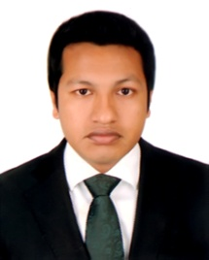  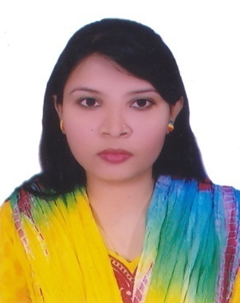  

CAREER OBJECTIVE:
Seeking responsibilities and opportunities in any areas where skill can be exercised and field of interests are also synchronized in order to develop and upgrade my career. I am willing committed individual.

EDUCATIONAL QUALIFICATION:
Name of degree | Institution | GPA/CGPA | Group/Subject
Bachelor of Business Administration | Sylhet International University  (Private University) | 3.12/4 | Business Administration
Higher Secondary Certificate | Madan Mohan University College  (Sylhet Board) | 3.60/5 | Business Studies
Secondary School Certificate | Jamalgonj High School  (Sylhet Board) | 4.56/5 | Business Studies

PREVIOUS EMPLOYMENT:
- Organization : Technext Limited.
Akhalia, Sylhet.
Duration : January 2018 to January 2019
Designation : Translator (English to Bengali)

- Project Works : FIVDB, BRAC etc.
- Organization : Mercantile Bank Limited.
Duration : 3months

Designation : Internee.

LANGUAGE PROFICIENCY:
- Language competency in English & Bengali (Both in speaking and writing).

COMPUTER SKILLS:
- Proficiency in MS Word, MS Power Point, MS Excel.
- PGD on computer diploma.
- Efficient in E-Mail and Internet Browsing.

SKILLS:
- Ability to work independently and with group.
- Capability of organizing and leading a group.
- Capability of communicating with people effectively.

EXTRA CURRICULUM ACTIVITIES:
- Reading Books & Magazine.
- Travelling & meet with new people.
- Watching Television.
- Sports.

PERSONAL DETAILS:
Father’s Name | : | Kazal Halder
Mother’s Name | : | Madhabi Halder
Present Address | : | Flat no. :6/2  369, Ekota,  Madina Market, Sylhet.
Permanent Address | : | Uttar Kamlabaz,  Sachna-3020, Jamalgonj, Sunamgonj, Sylhet.
Date of Birth | : | 14th May,1993
Height | : | 5'-3”
Nationality | : | Bangladeshi (By Birth)
Marital Status | : | Unmarried
Religion | : | Hinduism.
Gender | : | Male
Place of birth | : | Sylhet.

REFERENCE:
01. Name | : | Samir Biswas  Assistant Commissioner Land  Peoples Republic of Bangladesh  Borolekha, Moulvibazar.  Cell: +8801717534253  samir16843@gmail.com
02. Name | : | Mr. Abu Syeed Muhammed Abdullah  Assistant Professor & Head  Business Administration  Cell:+8801746461461  abdullah.aalo@gmail.com

DECLARATION

References

I hereby declare that the all information given above is true to the best of my knowledge and belief.



Khokan Halder

Date:

