MD MEHEDI HASAN 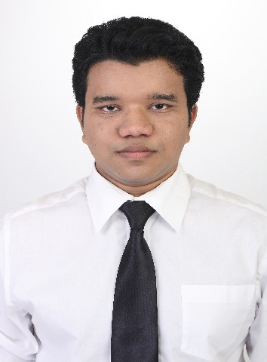
Care of
WO Abdus Salam,
360 Infantry Brigade,
Jalalabad Cantonment, Sylhet,
BANGLADESH
Mob: +8801773-687236, E-mail: salman197130@yahoo.com

Career Objective
Looking for hard and challenging job where I will have the scope to utilize my potentiality, adaptability and skill to do something innovate and from where I will be able to enhance my knowledge.
Education
GCE O LEVEL 2012-2017
British Council, Dhaka, Bangladesh c
DIPLOMA ENGINEERING 2017-2020
Electrical Engineering continuing
Personal Details
Father’s Name : Md Abdus Salam
Mother’s Name : Mrs. Shahanaz Parveen
Permanent Address : Village - Kalupara, Post Office - Daokandi,
Upazila- Paba, District- Rajshahi,
BANGLADESH
Date of Birth : 01/02/1995

1

Interests
Cricket,
Swimming,
Traveling,
Reading Novels

Language Competency

Bangla : Mother Tongue
English : Fluent both in Speaking and Writing
Hindi and Tamil : Fluent in Speaking

Computer Skills

Microsoft office, Outlook Express, Web Graphics, Sound and Video Editing.
Experiences
I have finished three month special Course on Basic Cabin Crew training in jobsA1.com
National Volunteer, Bogra, Bangladesh (Jan 2007 – Apr 2009)
Scouting, Bogra, Bangladesh (Jan 2006 –Apr 2012)
Receptionist & Asst. Manager at Wallawata hotel,
Colombo, Sri Lanka (Dec 2009 – April 2010)
Colombo city hotel, Colombo, Sri Lanka (July 2010 - Dec 2010)
Hotel Renuka, Colombo, Sri Lanka (Jan 2011 – Sep 2011)
Short Drama script writing in school (2008 – 2011)

International Telemarketing at Fortunaglobal (Pvt) Ltd (June 2010 – 2011)

(Call Center Executive)

Reference

Md Abdus Salam
Warrant Officer, 360 infantry Brigade
Jalalabad Cantonment,
Sylhet,
BANGLADESH
Mobile: +8801721-103841

2

