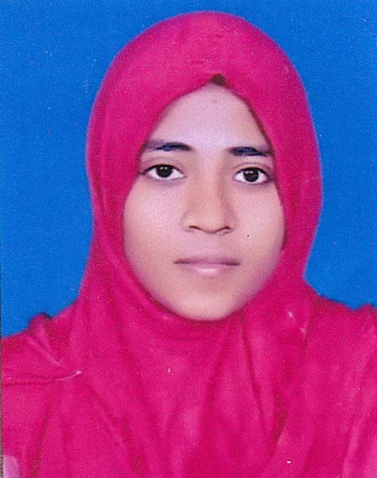
RESUME OF
MAKSUDA KHANAM SUCHI
Sunnia Mosque,
Hajipara, Chattogram
Contact No: +8801836060144
e-mail: maksudasuchi2018@gmail.com

CAREER OBJECTIVE:

To secure a challenging position in a reputable organization to expand my learnings, knowledge & skills to improve my practical knowledge through these activities also. I believe that my academic degree and working experience will provide me the necessary knowledge to handle any kind of challenging and also help me to build up career.

EDUCATIONAL QUALIFICATION:
Name of the degree  Master of science  (Appeared) | Institution  Chattogram Veterinary And Animal Sciences University | Group/subject  Food Chemistry And Quality Assurance | Result  (GPA)  Appeared
Bachelor (Hon’s) of Science  B.Sc(2018) | Chattogram Veterinary And Animal Sciences University | Faculty of Food Sciences & Technology | 3.24(out of 4.00)
Higher  Secondary Certificate (HSC- 2013) | Agrabad Women’s College,Agrabad,Chattogram | Science | 4.80
Secondary School Certificate(SSC- 2011) | Kalakakoli High School,Agrabad,Chattogram | Science | 5.00

LANGUAGE PROFICIENCY:
-Language competency in:
-English & Bengali (Both in speaking & writing)
-Hindi (speaking).
SKILLS:
- Ability to work independently & with group.
- Capability of communicating with people.

INTERNSHIP PLACEMENTS:
- Universiti Malaysiya Terengganu(UMT)
- Kishwan Snacks Ltd.
- Patiya Milk Chilling Center, Milk Vita
- Poultry Research & Training Center, CVASU
- Food Processing & Engineering Laboratory ,CVASU
- Banoful & Co.
- Fulkoli Food Products Ltd
- Marts Promots Ltd (Khulsi Mart)
- Apex Foods Ltd
- Training Institute for Chemical Industries(TICI)
- Bangladesh Council of Scientific and Industrial
Research, Chattogram(BCSIR)

COMPUTER SKILLS:
- Proficiency in MS Word, MS Power Point.
- Operating MINITAB.
- Good speed in typing English.

PERSONAL DETAILES:
Father’s Name : MD. Saiful Islam
Mother’s Name : Mahbuba Khanam
Present Address : Sunnia Mosque, Hajipara, Chattogram.
Permanent Address : Village: Charpara, P/O: Dublia, Thana: Pabna Shodor,
Dist: Pabna.
Date of Birth : 23 July, 1996
Height : 4’.10”
Marital Status : Unmarried
Religion : Islam
Gender : Female
Place of Birth : Brahmanbaria

REFERENCE:

1. Mr. Mohammad Shaokat Ali  Assistant Professor  Department of Applied Chemistry and  Chemical Technology  Faculty of Food Science and Technology,  Chittagong Veterinary and Animal Sciences University.  Mobile: 01825128942 | 2. Abdul Matin  Assistant Professor  Department of Food Processing &  Engineering;  Faculty Of Food Science & Technology;  Chittagong Veterinary & Animal Sciences University.  Mobile: : 01813543025
3. Dr. Zulfikar Alam (Shuvo)
MBBS, CCD (BIRDEM)
CMU (Ultra), DMU (Ultra)
Rajshahi Medical College, Rajshahi
Mobile: 01722976848

DECLARATION:

I references are that all information given above is true to the best of my knowledge.

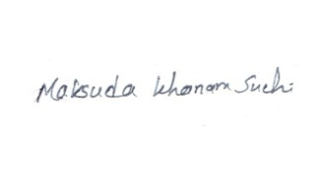

Signature

