Resume of
Masum Hussain
46, Vatatikor, Tilaghor, Sylhet.
Cell: 01761167833
E-mail : masumhussainbd@gmail.com

Career objective

Rendering of conceptual and organizational skills along with creativity, dynamism, enthusiasm and thus making position in corporate world. Moreover, enhancing and developing individual skill through all out efforts as well.

Personal details
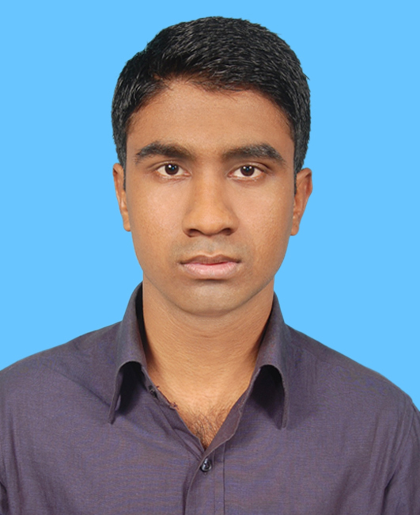
Name : Masum Hussain
Father’s Name : Jashim Uddin
Mother’s Name : Jahanara Begum
Permanent Address : 46, Vatatikor, Tilaghor, Sylhet.
Present Address : 46, Vatatikor, Tilaghor, Sylhet.
Date of Birth : 23 March, 1993
Nationality : Bangladeshi
National ID No. :19939196220000097
Birth registration no : 19939196220000145
Passport No : AC 1193808
Religion : Islam
Marital Status : Single
Blood Group : B (+ve)
Sex : Male
Weight : 62 KG
Height : 68 inches

Academic qualifications

Post- graduation | Master of Business Administration (MBA)  Passing Year: 2016  Major: Human Resource Management (HRM).  ID: 1611017021  CGPA: 3.50 on a 4.00-Point Scale  Institution: Leading University, Sylhet.
Graduation | Bachelor of Business Administration (BBA)  Passing Year: 2015  Major: Human Resource Management (HRM).  ID: 1201010202  CGPA: 3.70 on a 4.00-Point Scale  Institution: Leading University, Sylhet.
H.S.C. | Higher Secondary Certificate Examination  Passing Year- 2011  Group- Business Studies  Board- Sylhet  Result- GPA: 4.40 on a 5.00-Point Scale  Roll: 500487  Institution- Jalalabad Cantonment Public School and College
S.S.C. | Secondary School Certificate Examination  Passing Year- 2009  Group- Business studies  Board- Sylhet  Result- GPA: 5.00 on a 5.00-Point Scale  Roll: 500527  Institution- Jalalabad Cantonment Public School and College

Language proficiency
- Bengali (Mother tongue)
- English (Fluent in listening, speaking, reading and writing)
- Sylheti Dialect (local language)
Self-assessment
- Strong desire for leading an honest life with dignity.
- Hard working, sincere and eager to learn.
- Strong determination to attain goals.
- Strong analytical ability and communication skills.
- Comprehensive creative thinking and fast learning capacity.
- Efficient in teamwork and ready to accept challenges.
- Energetic and willing to take charges

Extra-curricular activities:
- Participated in Intra University quiz competition and won prize.
- Attended an online training program lasting 3 weeks on “International Business Environment and Global Strategy” at edx.cm from 29 September to 19 October, 2016
- Participated in Intra University debate competition and won prize.
- Participated in “Intra Leading University Model United Nations-2016” and won special mentioned award.
- Participated in Intra University job quiz competition and get a position in top 10.
- Member, Leading University Social Service Club.
- Participated in different sports competition in school and college level and won prizes.

Work experiences:
- Worked as an intern in Prime Bank Limited, Amberkhana branch, Sylhet from 21 September to 20 December, 2015
- I was involved with a coaching centre named MAVS Academy, Shibgonj, Sylhet as an English teacher.

Personality traits:
Proactive, religious, integrity, self-motivated, balanced, sincere, organizing, analytical, communicating effectively, positive & flexible, a good listener & follower etc.

Computer literacy
Office Applications- MS Word, MS Excel, Power Point, Web Browsing.
Interest in
- Participating in creative works.
- Participating in sports including cricket, football, chess, carom etc.
- Watching movies, Traveling, Listening music.

References
Prof. Md. Nazrul Islam  Dean & Head  Department of Business Administration  Leading University, Sylhet  Contact: 01718824376  e-mail: head_bua@lus.ac.bd | Md. Mahbubur Rahman  Assistant Professor (MIS)  Department of Business Administration  Leading University, Sylhet  Contact: 01717019305  e-mail: mahbub_200610@yahoo.com

