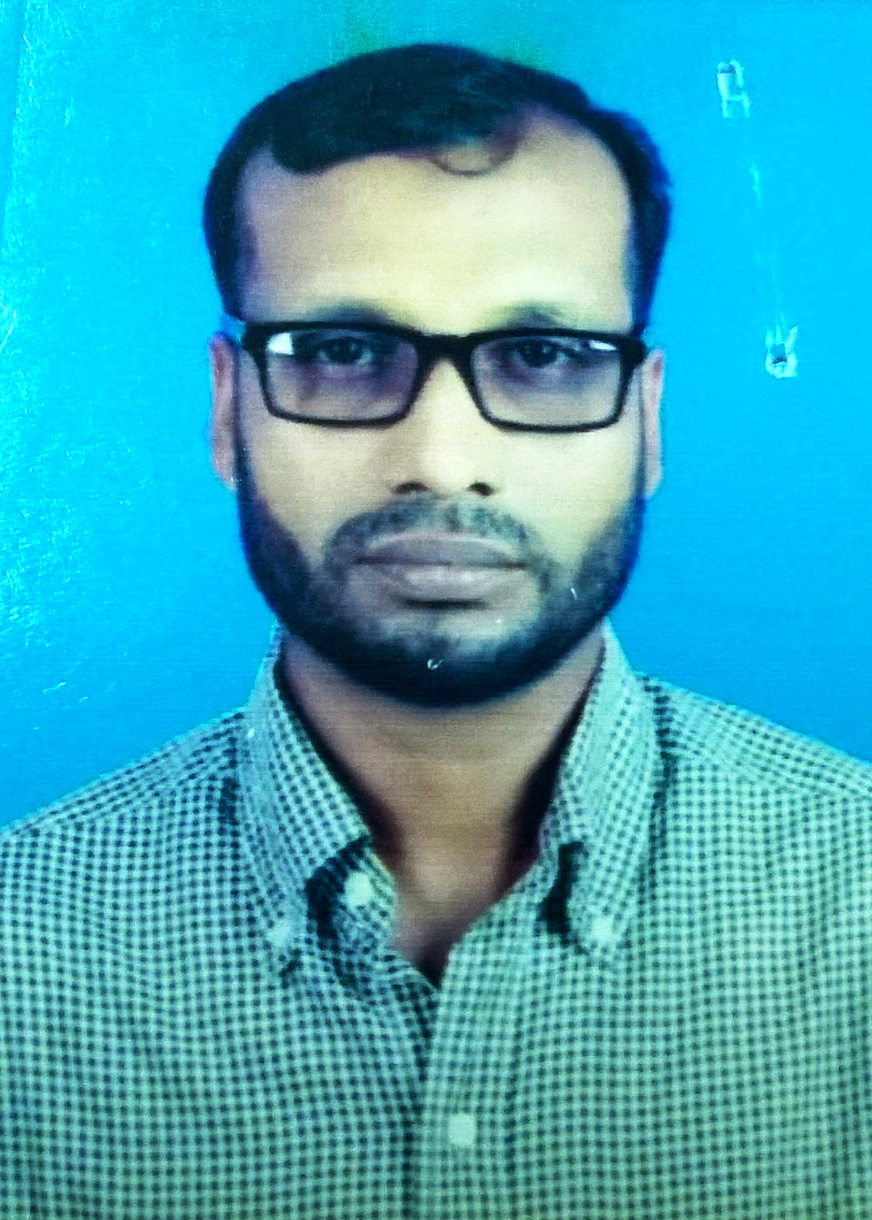
CURRICULUM VITAE
OF
MD Aminul Islam
Contact information:
Cell: 01743838582, email: aislam35049@gmail.com
Career Objective:
To build up a challenging career in a dynamic Organization where I can utilize my professional expertise that ultimately leads to jobs satisfaction.
Qualification:
1. Higer secondary school certificate (HSC)
Passed in 1997
2nd division
2. Secondary school certificate (SSC)
Passed in 1995
1st division
3. Basic trade in general mechanic
Passed in 1997
1st division, BTEB
Experience of Industrial job:
1. Foreman
Duration: 01 Aug 2018 to Till now.
Gazi cement Mills Ltd.
Kawadi, Charshindur, Palash, Narshingdi

2. Foreman
Duration: 05 Sep 2009 to Aug 2018
Holcim cement Bangladesh ltd
Meghna ghat, Sonar gaon, Narayngonj
3. Asst Foreman
Duration: 15 July 2007 to 15 May 2008
MHI Company (M.S.K Hayarng to MHI) Rabik
Jeddah, KSA
4. Mechanical fitter
Duration: 5 Feb 2001 to 15 Aug 2005
Shah cement industries ltd
West mukterpur, Munshiganj

5. Mechanical fitter
Duration: 05 June 1998 to 30 Jan 2001
Akij match factory ltd
West mukterpur, Munshiganj

6. Welder cum workshop fitter
Duration: 1st Jan 1996 to 30 Mar 1999
Sheikh metal engineering workshop
Mohammadpur, Dhaka

Computer Proficiency:
Ms Word, Ms Excel, Internet browsing, Email writing
Language Proficiency:
Both spoken & written Bengali & English also able to spoken Hindi.
Significant Qualities:
1. Have a expertise area of knowledge in maintenance & overhauling of Haver boucker, EEL, ENEXCO 6, 8 & 12 spout automotive Roto-packer machine.
2. Supevise and maintaining overall packing section activities in individual shift
3. Able to perform packing plant schedule & Preventive Maintenance of mechanical equipment & machineries.
4. Effective maintenance of Bucket elevator, Airside, Screw conveyor, Belt conveyor, Auto-truck loader, barge loader and etc
5. Highly experience in packing machineries, PLC based operating system.
6. Able to prepared equipment history, keeping data, performance monitoring & packing performance data
7. Able to perform and sufficient knowledge to perform individual shift packing target to achievement on time delivery for incoming customer
8. Monitoring and controlling packing weight variation through spout calibration and overhauling\
9. Have a good knowledge on safety working procedure on industrial maintenance & operation field.
Personal Statement:
Fathers Name : Late Abdul Khalek mistri
Mothers Name : Late Firoza Begum
Permanent Address : Vill:-Goadhory, PO:-Kalatiya, PS:-Keraniganj, Dist:-Dhaka
Date of Birth : 02.01.19
Marital Status : Married
Nationality : Bangladeshi (By birth)
Religion : Islam (Sunni)
Height : 5 ft 6 inch
Weight : 62 kg
Next Contemplation:
Looking for well reputed dynamic Organization to disclose my efficiency through sincere performance.
Reference:
Nur Nabi Md.Mostafa Khan
Manager Manager-Packing operation
Cell: 01755580788 Cell: 01755641990
Email: nur.nabi@holcim.com Email: mostafa.khan@holcim.com
Holcim cement Bangladesh Ltd. Holcim cement Bangladesh Meghnaghat,Sonar gaon,Naraynganj Meghnaghat,Sonar gaon,Naraynganj

Md. Aminul Islam

