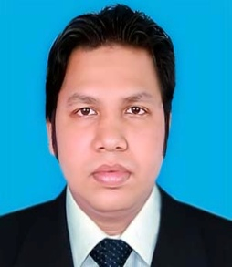
MINHAJ UDDIN PERVEZ

Vill: East Natmura, P.O: Belgaon
P.S: Banskhali, Dist: Chittagong
Mob: 01814-987931, 01715-265388
E-mail:- minhajuddin.pervez@yahoo.com

EXPERIENCE: 1. Worked 5 years in Sunman Group as Commercial Officer(Import) & Planning
Officer.

CAREER OBJECTIVE:

Interested to work in any reputed organizations where I can ameliorate my career avenue .

EDUCATION:

Name of Exam. | Educational Institution | Concentration | Result | Passing year
Master in Arts | Chittagong University | History | CGPA 3.04  out of 4.00 | 2012  (Exam held in April-May, 2013)
Bachelor in Arts (Hons). | Chittagong University | History | CGPA 2.84  out of 4.00 | 2011  (Exam held in  Jan-Feb , 2012)
Higher Secondary Certificate | Govt. Hazi Muhammad Mohsin College | Humanities | CGPA 4.00  out of 5 | 2006
Secondary School Certificate | Natmura Pukuria High School | Science | CGPA 3.25  out of 5.00 | 2003

COMPUTER PROFICIENCY:

Diploma in Computer | - MS WORD  - MS EXCEL  - BANGLA TYPING  - PHOTOSHOP  - INTERNET

BIOGRAPHY:

Father’s name : Late Shamsul Kabir
Mother’s name : Late Showkat Ara Begum
Mailing address : Flat B3, Water Lily, Green Leaf, 129/148 Baggona,
M.R Siddique Gate, Lalkhan Bazar, Chittagong
Permanent address : Village: East Natmura, P.O: Belgaon
P.S: Banshkhali, District: Chittagong
Date of Birth : 07. 07. 1987
Sex : Male
Nationality : Bangladeshi( By birth)
NID no : 1594314873702
Religion : Islam
Marital Status : Single

REFERENCES:

1. Dr. Mohammad Ali Chowdhury 2. Mr. Md. Basir Uddin
Professor Assistant Vice President &
Department of History Head of Branch
University of Chittagong Jamuna Bank Ltd.
Chittagong, Bangladesh Anderkilla Branch, Chittagong
Cell: 01712033857, 031-2552716 Cell- 01716-431270, Tel: 031-617945-6
E-mail- alihist_cu81@yahoo.com Email: abasirfb@gmail.com

I do solemnly declare that the above-mentioned information is correct.

_______________
Signature with date

