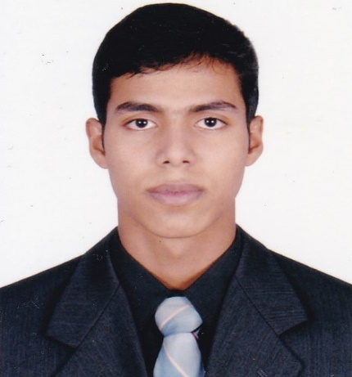
Curriculum Vitae

Mosaddek Hossain

CONTACT INFORMATION
Address : Vill: Eklashpur, P.O: Eklashpur Bazar,
P.S: Begumgang, Dist: Noakhali.
Mobile No : 01881912345
E-mail : mh.civildpi@gmail.com
CAREER OBJECTIVE
To work in a challenging Civil with a scope of future progress, applying my academic knowledge and working capability. I would like to welcome the chance to work as part of a dynamic working team where I could make a significant contribution while developing my skills yet further.
PERSONAL PARTICULARS
Date of Birth : 28-05-1998
Nationality : Bangladeshi (by Born)
Gender : Male
EDUCATION
- Diploma In Engineering
Year of Passing : 2018
Department : Civil
GPA : Appeared
Institute : Dhaka Polytechnic Institute, Dhaka.
Board : Bangladesh Technical Education Board.(BTEB)
- S.S.C (Secondary School Certificate)
Year of Passing : 2014
Group : Science
GPA : 4.54
Board : Technical Board
School : Noakhali Technical Training Center, Gabua Noakhali.
SUMMARY OF SKILL
- Skills Of Civil Department :
- Drawing Operating System : AUTO CAD (2D +3D) , Revit.
- Practically Estimate Hand Calculation
- Design of Building
- FAR Calculation
- Site Supervision
- Skills Of Computer :
- Operating system : Windows XP, Windows-7, Windows-8- Windows-10
- Office suit : MS Word, Excel ,power point
- Skills Of Language :
- Bengali : Mother language.
- English : Reading- Good, Writing-Good, Speaking-Good
- Skills Of Confident in Presentation :
- A Good Team Player
- A Proactive Organizer
- Able to work under pressure
- Like to take and meet challenge
- Completion work always in time
TRAINING AND WORK EXPERIENCE

- Industrial Training -3 (Three) month :
Housing And Building Research Institute, Mirpur, Dhaka.
- Experience of Job :
- Works Under The Contructor For The Two Month Of The Construct Work.
MD. Mukter Hossen, Cell no: 01840641339.
- The National H R Laboratory Ltd.(Part Time of Five Month)
Call no : 01818025396
PERSONAL INFORMATION

Fathers Name : Mosaddek Hossain
Mothers Name : Shahena Akter
Permanent Address : Vill:Eklashpur , P.O: Eklashpur Bazar,
P.S: Begumgang, Dist: Noakhali
Religion Status : Islam
Marital Status : Unmarried
Height : 5’6”
Blood Group : O+
HOBBIES & INTEREST
- Read Books
- Traveling
- Cooperate With The People.
- Be Honest On The Way And Speaking The Truth.
REFERENCE
Name : Amir Hossen Khan
Designation : Instractor in Civil Department
Dhaka Polytechnic Institute,Dhaka.
Phone : 01553226629

Signature

Date:………………….. Mosaddek Hossain

