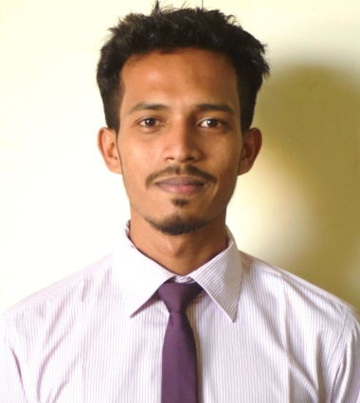

CURRICULUM VITAE

OF

Nahid UDDIN

Address:51/A Jollar Par, Sylhet
Mobile No: +8801643802913
Email: eftekharnahid411@gmail.com

E-mail : sohelrana_12@yahoo.com
Mobile No: 01722826455

CAREER OBJECTIVE

To enhance my knowledge and capabilities by working in a reputed organization that prides itself in giving substantial responsibility to my new talent.

EDUCATIONAL QUALIFICATION

B.Sc IN EEE (ELECTRICAL & ELECTRONIC ENGINEERING)
Institution : Metropolitan University, Sylhet
Department : EEE
Passing Year : 2019
Result : Appeared

HIGHER SECONDARY SCHOOL CERTIFICATE (H.S.C)
Institution : Chattagram Biggan College
Board : Chittagong
Group : Science
Passing Year : 2014
Grade Point : 4.00 (Out Of 5)

SECCONGDARY SCHOOL CERTIFICATE (S.S.C)
Institution : Jafar Nagar Aparna Charan High School
Board : Chittagong
Group : Science
Passing Year : 2012
Grade Point : 5(Out Of 5)

Computer Skills:

Microsoft Word, Microsoft Excel, AutoCad, PhotoShop

EXPERIENCE

- Working on Robotics.
- Achieved best rover award in 4th Annual Camp arranged by Metropolitan University Rover Scout Group.
- First Runner up in Adex Engenius 2017 Competition at Ahsanullah University of Science and Technology.

PERSONAL INFORMATION

Name : Nahid Uddin
Father’s Name : Harun Ur Roshid
Mother’s Name : Nur Nahar Begum
Date of Birth : 1st Jan 1996
Gander : Male
Marital Status : Unmarried
Nationality : Bangladeshi (By Birth)
Religion : Islam (Sunny)
Height : 5’7”

MAILING & PERMANENT ADDRESS

Present addresses: Permanent Address:

Name : Nahid Uddin
Village : Nunachora
Post : Sitakunda-4310
Thana : Sitakunda
District : Chittagong
Name : Nahid Uddin
Village : Jollar Par
Post : Sylhet-3100
Thana : Sylhet Sadar
District : Sylhet

1/K.m Riaz uddin
Excutive
Agrani bank Ltd.
koba Branch.

LANGUAGE PROFICIENCY

Fluent in Bangla and English.
Excellence at writing, spoken english and listening.

PERSONAL INTEREST

» Reading books and playing cricket & Football.
» Creative thinking study, playing, traveling, Performing, Social activities.

Declaration REFARANCE

I, hereby, declare that the information stated is correct to the best of my concern will be granted as liable if otherwise.

Robi Kormokar
Senior Lecturer
Department of EEE
Metropolitan University, Sylhet
Mobile: 01793929506
Email: robi@metrouni.edu.bd

Managing
Future Design Inc.
H#45(d-1), R#5, Sec. #

Cell: 01711-529520

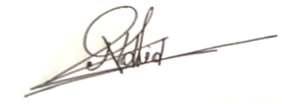
Date:02.05.19 Signature

