Fahmida Rahman Semu | 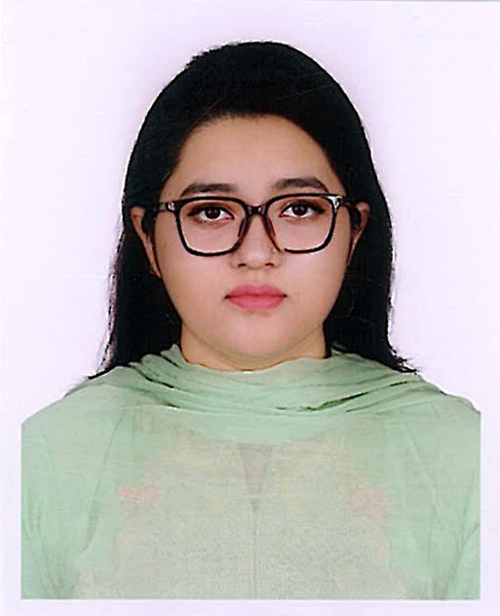  H-16/1, Flat-P4, Road-10/A,  Sector-10, Uttara, Dhaka.  semurahman10@gmail.com +8801618708800

CAREER OBJECTIVES |  |  | To work in a challenging position that will take full advantage of my education, skill and experience as well as open a new dimension of understanding and bearing required for success as a professional.
WORK EXPERIENCE |  |  | Thesis Paper-Malnutrition of Street Children  Project-ENFHM, GQN, Bangladesh Rice Research Institute (BRRI)  Key responsibilities included:  - Perform filed survey and record data for statistics  - Data entry  - Data analysis  - Sampling designing  - Interpretation and project paper writing
QUALIFICATIONS |  |  | Masters of Science, Applied Statistics  Institution : East West University  Result : On going  Bachelor of Science, Applied Statistics  Institution : East West University  Year : 2019  Result : 2.99  HSC  Institution : Dhaka Imperial College  Group : Science  Year : 2014  Result : 4.80 (out of 5)  SSC  Institution : A AM High School  Group : Science  Year : 2012  Result : 4.75 (out of 5)
SKILLS |  |  | - Strong presentation skills.  - Able to work within tight schedules.  - Good command in both oral and written English.  - Time maintainer, Honest and Sincere  - Posses qualities of solve problems  - Consummate in Microsoft Word, Microsoft Excel, and Microsoft Power Point, SPSS, R Programming.
INTERESTS |  |  | - Going to the gym  - Reading Books  - Travelling
EXTRA CURRICULAR ACTIVITIES | - Work as a Joint Head Publicity Deputy Officer at Alpha Beta Statistics club, East West University.  - Executive member at Agro Industrialisation Club, East West University.
ACHIEVEMENTS
- Certified 81% in Foundation Grammar and writing at Mentors Dhaka.
- Awarded second position of “International Mother Language Day-2018” Quiz Competition, East West University Information Club, East West University.
- Champion at “SOCIAL DEVELOPMENT PLAN COMPETITION” as requirement of the course AST306/AST-307 (Social Statistics and social development).
- Worked as a volunteer in the International conference on Analysis of Repeated Measures Data,2016.
- Attended the pre-conference workshops of International conference on Analysis of Repeated Measures Data,2016.
- Participate at East West University inter Department debate championship 2017 and won two round out of three also announced as a Best debater.
PERSONAL INFORMATION |  | Father’s Name: Md. Moklesur Rahman  Mother’s Name: Nahida Akter  Date of Birth: 1st January 1997  Nationality: Bangladeshi  Marital Status: Married
REFERENCES |  |  | Dr. Md. Manzoor Elahee Aftab Uddin  Professor, Department of Philosophy Sr. Manager (Admin)  Jahangirnagar University. Elite Group of Industries  +8801716-212670. +8801678708800  elaheemanzoor@gmail.com aftab@aquamtt.com
CERTIFICATION |  | I, the undersigned, certify that to the best of my knowledge and belief that this Curriculum Vitae correctly describes my qualification, my experiences and myself.
Yours Faithfully

----------------------------
(Fahmida Rahman Semu)

