Curriculum Vitae
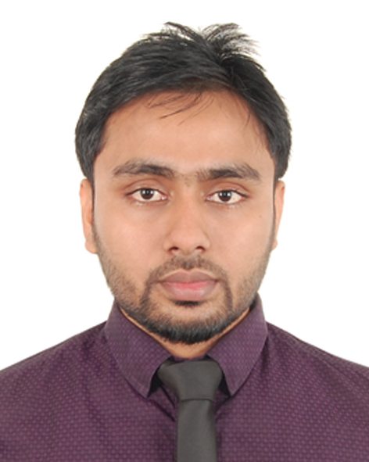
Of
Sibbir Ahmed

Mailing Address:
Sibbir Ahmed
3/A- Islam Villa,Nurjahan Residential Area,
Gutatikor, Kadamtaly, Sylhet – 3100,Bangladesh
Cell No. : +8801747516512, E-mail : shibbir.ahmed77@yahoo.com

Career Objectives:
To pursue a highly rewarding career, seeking for a job in challenging and healthy work environment where I can utilize my skills and knowledge efficiently for organizational growth and I will have the opportunity to assert strong sense of responsibility to know about the real world laid ahead of me.

Educational Qualification:
Exam : B.Sc. in Civil Engineering
Session : 2012 - 2015
Department : Civil Engineering
Institution : Leading University, Sylhet
Result : 2.89 out of 4.00

Exam : Higher Secondary School Certificate (H.S.C.)
Session : 2009 - 2010
Passing year : 2011
Group : Science
Result : A
Institution : Jalalabad University College, Subhanigat
Board : Sylhet

Exam : Secondary School Certificate (S.S.C.)
Passing year : 2009
Group : Science
Result : A
Institution : Hazrat Omar Faruque (R). Academy, Bishwanath
Board : Sylhet

Undergraduate Thesis:
Title: Capacity Analysis & Performance Measurement of Five TWSC Unsignalized
Intersection of Sylhet City.
Key Contents: Unsignalized; Capacity; Flow; Level of service; HCM2000.

Supervisor: Tanay Datta Chy.
Lecturer
Department of Civil Engineering
Leading University
E-mail :tanaydatta@ymail.com

Job Experience:
Working as a “Customer Support Officer” at Premier Cement Mills & Factory Ltd. from 1st October, 2016
Head Office : T.K Bhaban,12th floor, 13 Kawran Bazar, Dhaka 1215, Bangladesh

Training Courses:
- Spoken English, from “Learning Point” Bishawanath, Sylhet at 2009
- Basic Computer Course, from “Ananda Multimedia” Zindabajar, Sylhet at 2011
- IELTS , from “Mentors” Zindabajar, Sylhet at 2014

Workshops:
- Workshop on “How to increase the proficiency on English language ” Organized by British Council at Rose View Complex, Upashahar, Sylhet in 2014
- Workshop on “Team Building & Conflict Management” Organized by United Nations Youth and Students Association of Bangladesh (UNYSAB), Conducted by Lantern HR Solutions on 30th January, 2013.
National and International Conferences :
- Acted as a Chairperson of UNHRC ; United Nations Human Rights Council committee of Intra Leading University Model United Nations - 2016
- Acted as a Director of UNHRC ; United Nations Human Rights Council committee of Rajshahi University Model United Nations - 2016
- Acted as a Director of UNHCR ; United Nations High Commissioner for Refugees committee of Chittagong University Model United Nations - 2016
- Shahjalal University of Science and Technology Model United Nations (SUSTMUN -2012), Country -France under SOCHUM Committee.
- Bangladesh International Model United Nations (BIMUN) –2012,Country – Botswana Under SOCHUM Committee.
- London International Model United Nations (LIMUN) –2014,Country – Mauritania Under United Nation Environment Programme (UNEP) Committee.
- Dhaka University Model United Nations (DUNMUN) –2014,Country – Senegal Under World Bank Committee.
- Bangladesh International Model United Nations (BIMUN) –2015,Country – Brazil Under United Nation Environment Programme (UNEP) Committee.

Computer Skill:
Experienced in -- Design Applications ( AutoCAD and Etabs)
Windows XP, Windows 7, Windows 8, Office Applications ( MS Word, MS Excel, MS PowerPoint.) Internet : Browsing & E – mail Literacy.

Language Proficiency:
Good command over colloquial Bengali and English.
Interests & Hobbies :
Traveling, Swimming, Reading newspaper, Gardening, working for the humanity.
Personal Information :
Father’s Name : Bashir Ahmed
Mother’s Name : Fatema Begum
Date of Birth : 28th December, 1992
Nationality : Bangladeshi
Religion : Islam
Blood Group : O+(ve)
Present Address : House : Islam Villa (2nd floor - A).Nurjahan Residential
Area, Gutatikor, Sylhet- 3100
Permanent Address : Vill.- Shorbajpur, P.O – NazirBajar, Union – Lalabajar,
Upo-zilla – Dakkin Surma, Dist – Sylhet
Key Qualifications :
- A highly numerate with excellent communication skill.
- Analytical, Innovative, Self-motivating, Confident.
- “Can Do” attitude and “Well Done” skill.
- Able to lead or to work as part of a team.
- Welcomes new challenges, especially if they involve implementing and developing schemes.
- Able to develop and manage a portfolio.

Co-Curricular Activities :
- A founder and Working as a ‘Secretary at Management and Coordination’ at the “Mrinmoy”- A non-profit Organization.
- Secretary at Leading University Model United Nations (LUMUNA).
- A member of United Nations Youth And Student Association Of Bangladesh(UNYSAB).

References :
1. Prof. Dr. Mushtaq Ahmed, 2. Syed Mustakim Ali Shah
Head of the Department, CEE,SUST. Senior Lecturer
Department of Civil and Environmental Engineering Department of Civil Engineering
Shahjalal University of Science and Technology, Sylhet Leading University, Sylhet.
E-mail: mushtaq_cee@yahoo.com E-mail:mustakim.bd@gmail.com
Declaration :
I, the undersigned declare that the information specified in this Resume is true to the best of my belief and knowledge and correctly describes my experience and myself.

Sibbir Ahmed

