SUBRATO MUKHERJEE
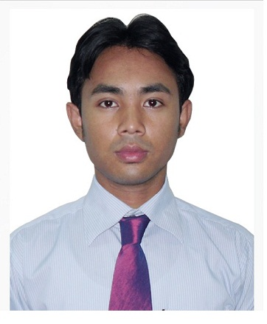
Senior Support Engineer
Address: Monepuri Rajbari 23,Sylhet
Mobile : 01711-041150
E-mail: subrato.mukherjee82@gmail.com

Career Objective:
Accomplishment driven Senior Technical Support Engineer with over 12 years solid experience and expertise in Operations management, Supervision, Training and Development, Workforce management, Quality management as well as enhance department efficiencies amidst fast-paced working environments. Seeking a Challenging position in IT technical support and IT operations as Senior Associates/Team leader/Associate manager, EDP,in-charge,IT-Officer

Experience
2010/06 – Present Senior Technical Support Engineer
Banglalion Commucation Ltd
Silver Tower(11th Floor),52 Gulshan Avenue,Circle-1 Dhaka 1212

Responsibilities:
Provided L2 support for customer service in the technical support division.

Solved critical problems and provided detailed information on the topic of problems to Technical Engineers.

Created and delivered solutions that met corporate objectives tied to business and technology performance.

Achieved high level of customer satisfaction through patient and methodical approach to problem resolution with majority of calls resolved as per company’s requirement.

Training provided to new Technical Support Engineers regarding Technical information, advice and technical support to a variety of clients, both professional and amateur, about problems with photographic equipment and techniques.

2004/01-2010/05 Senior Technical Support Engineer
Manor IT LTD
Galleria Shopping & Apartment Complex,level-5,Sylhet
Responsibilities:

1.Technical support and troubleshooting to wireless links
2.Fiber, Radio, VPN, DSL, Dialup installation and LAN setup.
3.Windows XP, 2000 server/ professional, Linux server configuration
4.configure /setup TCP / IP
5. Configure DHCP server, DNS server, PROXY server, MAIL server,
Configure Database Server, Firewall, web server, Antivirus Server and maintenance.
6.Cofigure and implement High Range WiFi Hotspot Network.
7.Point-To-Point Link Connectivity ETC.
8.Successfully design and configure Fiber Optics network in Metropolitan Area

Education

2008 National University
M.S.C in Mathematics
2nd class

2006 Shahjalal University of Science & Tecnology
Post Graduate Diploma in IT
CGPA :2.58 out of 4

2004 National University
B.S.C in Mathematics
2nd class

2000 Modon Mohan College and University,Sylhet
H H.S.C in Science Group
2nd class

1998 Rosomoy Memorial High School,Sylhet
S.S.C in Science Group
1st class
1st clas

Certificates:
Cisco Certified Network Associated

Communication Skills:
1. Excellent in spoken and written Bangla.
2.Good in spoken and written English.
3.Good typing speed .

Reference:
Reference: 01

Name: Muhammed Zafar Iqbal
Designation :Head Of Dept Computer Science and Engineering
Organization :Shahjalal University Of science And Technology
Mobile:01711339436

Reference: 02

Name: Md. Masum
Designation : Asst. Professor Computer Science and Engineering
Organization :Shahjalal University Of science And Technology
Mobile: 01711736248
Email: Mmasum@Gawab.Com

Personal Details:
Name | : | Subrato Mukherjee
Mother's Name | : | Suva Mukherjee
Father's Name | : | Asutush Mukherjee
Gender | : | Male
Marital Status | : | Married
Nationality | : | Bangladeshi
Religion | : | Hindu
Permanent Address | : | Monepuri Rajbari 23,Sylhet ,3100
Mobile No | : | 01711041150

Email | :subrato.mukherje82@gmail.com
Date of Birth | : October 15, 1982
Physical Condition | : Good and Sound Health

Confidence:

I am a smart, young, energetic, dynamic, an outgoing pleasant personality and self-starter, strong Inter-personal skill with an ability to work at a high pace on one’s own initiative. I am working since 12 years as a Technical support Engineer and I am Expert on it.

Thanks

Subrato Mukherjee
Date:10/03/18

