Curriculum Vitae

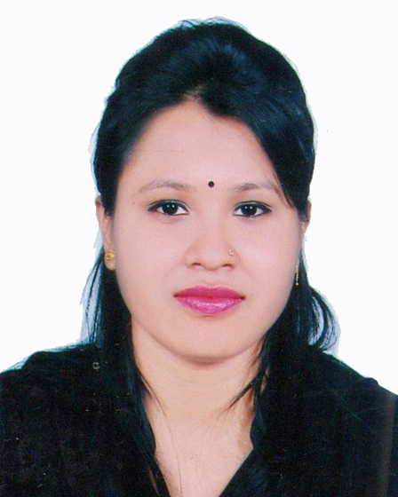

Of
Susmita Deb Priya

Contact Address:

Moubon- 10, A/3
Subhanighat, Sylhet- 3100.
Cell: +8801792778948
Email: susmitapriya1994@gmail.com

Objective
Objective Career

To obtain a responsible position through which I can utilize my knowledge, enhance my skills as well as can acquire the ability to face a high level of challenges, and get myself provided with varied experience and at the same time I would like to contribute by best to the organization.

Educational Qualifications

Masters of Business Administration (MBA):

Institution : Metropolitan University, Sylhet.
Session : 2018-2019
Major : Finance & Banking
Result : CGPA- 3.75 (Upto 2nd Semester- Out of 4.00 on scale)

Bachelor of Business Administration (BBA):

Institution : Metropolitan University, Sylhet.
Session : 2013-2017
Passing Year : 2017
Major : Finance & Banking
Result : CGPA- 3.78 (Out of 4.00 on scale)

Higher Secondary Certificate (H.S.C):

Group : Business Studies
Passing Year : 2013
Result : GPA- 4.50 (Out of 5.00 on scale)
Institution : SAARC International College Bangladesh, Sylhet.
Board : Sylhet.

Secondary School Certificate (S.S.C):

Group : Science
Passing Year : 2011
Result : GPA- 3.19 (Out of 5.00 on scale)
Institution : Kazi Jalal Uddin Girls High School, Sylhet.
Board : Sylhet.

Computer Knowledge

- Able to prepare any type of documents with MS word & Excel
- Able to prepare any type of slide with MS PowerPoint
- Having knowledge on Internet browsing and e-mail, corresponding.

Self Assessment

- Strong desires for leading an honest life with dignity.
- Aspiration to build a career showing superior performance.
- Energetic, Sincere, Hard working, honest and Dutiful.
- Able to work at any time at any place.

Language Proficiency

- Bengali: Good communication & presentation skills in Bengali as a native speaker
- English: Good communication & presentation skills in English as a second language.

Personal Details

Father’s Name : Bijoy Deb
Mother’s Name : Nipa Deb
Date of Birth : 29th August, 1994
Permanent Address : Moubon- 10, A/3
Subhanighat, Dist. Sylhet.
Present Address : As Above
Marital Status : Unmarried
Nationality : Bangladeshi (By Birth)
Gender : Female
Religion : Hindu (Sonaton)
Experience:

I have been successfully completed Internship in City Bank Ltd. at Bandar Bazar Branch, Sylhet for 3 months.

Reference :
1. Debashish Roy
Assistant Professor
Department of Business Administration
Metropolitan University, Sylhet.
Cell: 01717534079
1. Nikhilesh Chandra Dey
Deputy Manager (Cash)
Bangladesh Bank, Sylhet Branch
Taltola, Sylhet.
Cell: 01552439792

Proclamation:

Hereby, I declare that all information stated here is true to the best of my concern.



Susmita Deb Priya

Date:------------------------------------

