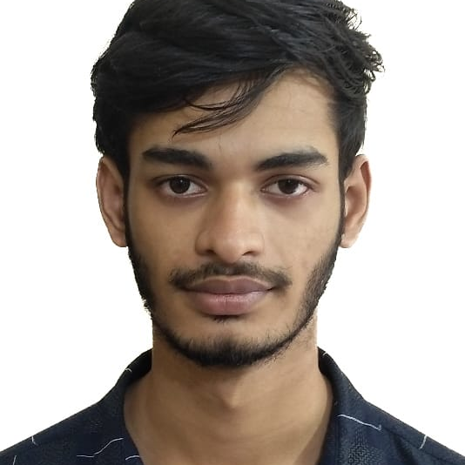
Udoy Roy Debasish

EDUCATIONAL QUALIFICATIONS

BACHELOR OF SCIENCE(ENGINEERING)
Subject: Computer Science and Engineering
2024: Running
Institution: Metropolitan University Bangladesh, Sylhet, Bangladesh
HIGHER SECONDARY CERTIFICATE
Group: Science
Passing Year: 2020
Result: 4.00 out of 5
Institution: Sylhet Commerce College, Sylhet, Bangladesh
SECONDARY SCHOOL CERTIFICATE
Group: Science
Passing Year: 2018
Result: 3.83 out of 5
Institution: Sylhet Government Pilot High School, Bangladesh

SKILLS
WEB DEVELOPMENT
Front End: Html5, Css3, Tailwind, Bootstrap5, JavaScript, ReactJS, MambaUI, Kitwind Back End: JavaScript, Nodejs, expressjs, ECMAScript 6
Database: MongoDB, MySQL Authentication: Firebase
Tools: VsCode, GitHub, Google Chrome, Chrome Devtool
Extra: C,C++, Python, Java

EXPERIENCE
1 year work experience at Arrownet Broadband Internet company as a customer support executive

EXTRA-CURRICULAR ACTIVITIES
Problem Solving: I enjoy programming, that’s why I have solved problems from code forces, Hacker rank, and many other websites.
LANGUAGE PROFICIENCY
● Bengali- Native
● English- Comfortable
● Hindi- Familiar
● MOI(Medium of Instruction) - 4 years bachelor’s degree curriculum in English
PERSONAL DETAILS
Name: Udoy Roy Debasish
Father’s Name: Manadhir Roy
Mother’s Name: Anjana Rani Roy
Date of Birth: 20 October 2001
Permanent Address: Moddho Tahirpur, Sunamgonj, Bangladesh
Marital Status: Unmarried
Nationality: Bangladeshi
Gender: Male
Religion: Hindu

CONTACT
Phone: +8801608623917
Email: debashishroyu123@gmail.com
Address: 56 Amberkhana Borobazar Sylhet
PROCLAMATION
Hereby, I declare that all information stated here is true to the best of my concern.
SINCERELY YOURS,
Udoy Roy Debasish

