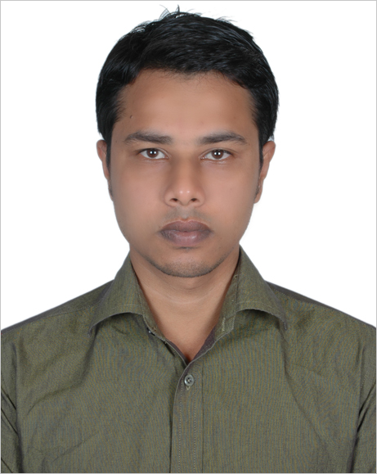Curriculum Vitae of

YOUSUF AHMED
Area; Khojar Khola 441/D, 25th no ward.
Thana :South Surma,
Post Office: Sylhet-3100,
District: Sylhet
Country: Bangladesh
Contact: +8801778073292
E-mail: yousuf143s@gmail.com

Career Objective
To work in an environment where can utilize what I have learnt theoretically and apply them to practical situations while simultaneously refining my extensive set of personal skills.
Experience
> 3 month internship in Islami Bank Bangladesh Limited,South Surma branch,Sylhet.

> Worked as an Accountant in Sheba Transport Agency head office Sylhet from February 2011 to April 2014 (3 years 2 month).

>Worked as a Samsung Experience Consultant in Samsung Mobile from 24-01-2015 to 26-07-2017

>Now working as a Territory Sales Assistant in Market Access Providers Limited(BATB TSA Operation) from 01-08-2017

Academic Qualification
Bachelor Of Business (Hons)  Major: Finance  (2010-2015) | Institute: Sylhet International University  Result: 2.80 of scale 4.00  Passing Year: 2015
Alim  Arts | Institute: Boroikandi Islamia Alim Madrasah  Result: GPA 3.75 of scale 5.00  Board: Madrasah  Passing Year: 2007
Dhakil  Arts | Institute: Boroikandi Islamia Alim Madrasah  Result: GPA 4.17 of scale 5.00  Board: Madrasah  Passing Year: 2005

Technical Knowledge

>Proficiency in operating personal computers and software packages like Microsoft office (e.g., MS Word, MS PowerPoint, MS Excel), Adobe Photoshop, etc

>Fluent capacity to surf throughout internet.

Language Skill

Bangla : Fluent and effective in oral, reading & writing as a Mother Language.
English : Fluent and effective in oral, reading & writing as an International Language.

Looking For | : | Entry Level Job
Available For | : | Full Time
Preferred District | : | Anywhere in Bangladesh
Preferred Organization Types | : | Financial Organization
CAREER AND APPLICATION INFORMATION

Other Activities

- Participate in “Small Business” Fair 2013 held on Sylhet International University’s campus.

Personal Attributes

- Self motivated and can act on own initiative.
- Being responsible for accuracy of a till & keeping the till safe, tidy and clean.
- Excellent negotiation and problem solving skills.
- Flexible with working hours.
- Adaptable and have a positive attitude towards change.
- Motivated, persuasive and goal orientated.
- Working efficiently under pressure.

Personal Information

Name : Yousuf Ahmed
Father Name : Md. Rafiqul Hoque
Mother Name : Parvin Begum
Date of Birth : 17th Feb 1990
Permanent Address : Khojar Khola 441/D, 25th no ward.
P/O :Sylhet-3100, Thana :South Surma,
Dist: Sylhet

Present Address : That
Religion : Muslim
Marital Status : Married
Contract : +8801778073292

References

 | Reference : 1 | Reference : 2
Name : | Emon Ahmed | Abdul Latif
Organization: | Sheba Transport Ltd | Sylhet International University.  Bagbari Sylhet
Designation : | Owner | Head of Department.
Mobile : | 01711-012536 | 01711-996032

I certify that all information stated in this resume is true and complete to the best of my knowledge. I authorize the respective authority to verify the information provided in this resume.

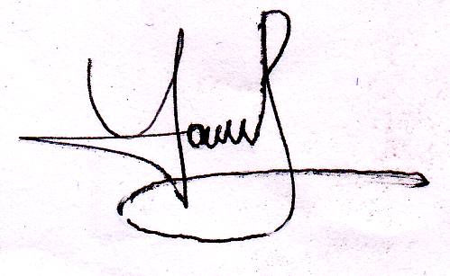SIGNATURE

Yousuf Ahmed

