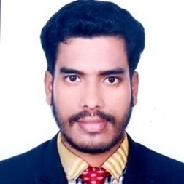
CURRICULUM VITAE
Pradyut Ranjan Talukdar
Present Address :House Mohona 84, block-A, Pathantula, Sylhet.
Mobile:(+88)01798285897
E-mail: prt_41@yahoo.com

Career Objectives:

To obtain a position that will allow me to utilize my technical skills, experience and willingness to learn in making an organization successful.

Key Qualities:
- Able to Work under pressure.
- Have a good interpersonal skill.
- Analytical ability.
- Helpful
- Team work
- Multitasking and able to keep confidentialities.

Educational Qualification:

Education(Specification) | Certification/Major | Institution | Result | Passing Year
Secondary School Certificate | Science | Giridhar High School, | GPA: 3.81  (out of 5) | 2012
Higher School Certificate | Science | Shalla  College | GPA: 4.70  (out of 5) | 2014
B.Sc Engineering in CSE | CSE | Sylhet International  University | CGPA:2.72  (out of 4) | 2019

Computer Skills:

  - Operating System: WindowsXP.
  - Language: C, C++ ,Basic java programming language.
  - Project : Blood Bank manage attendance management system ment system. Attendance management system,
  - Web Technologies : HTML, CSS. javascript.
  - MSWORD,MSOFFICE,POWERPOINT,Database access.

Activities and Interests:
- Reading Books
- Internet Browsing
- Traveling.
- Playing cricket

Personal Details:
- Name: Pradyut Ranjan Talukdar
- Father’s Name: Pratap Ranjan Talukdar
- Mother’s Name: Prabha Rani Talukdar
- Date of Birth: 1st September 1994.
- Permanent Address: Habibpur, Anandapur-3050, Shall, Sunamganj.
- Home District:Sunamganj.
- Nationality: Bangladeshi.
- Sex: Male.
- Marital Status: Unmarried.
- Religion: Hinduism.
- Blood Group: B+ (‘ B ’ Positive).
- NID:19949018671000292.
- Birth Registration: 19949018671008538

Reference(s): Abdul Awal Ansary
Assistant Professor of CSE & Director at CRTC Sylhet International University, Sylhet.
Email: awal_sust@ yahoo.co.in
Mobile: (+88)01196128260

Khaled Hossain
Head & Assistant Professor Of CSE
Sylhet International University. Email:Khussain@siu.e du.bdMobile: (+88)01712219040

Certification:
I, the Undersigned, clarify that according to my best of knowledge and belief, the resume correctly describes my qualification and me.

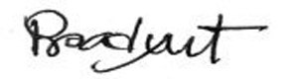
..................................
(Pradyut Ranjan Talukdar) Date:22/08/2019

