Curriculum Vitae

Md. Shafiur Rahman
Paharika-16/2,
Uttor Pir Moholla, Sylhet.
msrahmanjony @gmail.com
Cell No: 01938976621
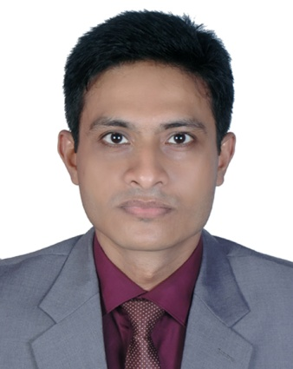

Position:
Career objective
Encounter challenge with wisdom to build a career that required creativity, honesty, hard working, sincerity, patience and brilliance. Moreover, gain utmost competence in the field of any sector to enrich my job as to give better service to my institution, men, society and country.

ACADEMIC QUALIFICATION

- Master of Business Administration (MBA)

Name of the Institution: Metropolitan University, Sylhet.
Year of Completion: 2014.
Major of Study: Human Resource Management.
Result: CGPA 3.78 (on 4.00 points scale).
Medium of Study: English.

- Bachelor of Arts (BA)

Name of the Institution: Open University.
Year of Completion: 2012.
Result: CGPA 2.68 (on 4.00 points scale).
Medium of Study: Bengali.

(03) Higher Secondary Certificate (HSC)

Name of the Institution: Gouripur govt. college.
Year of Completion: 2000.
Group: Science.
Board: Dhaka.
Result: First Division (Marks: 650).
Medium of Study: Bengali.

(04) Secondary School Certificate (SSC)

Name of the Institution: Gouripur R.K govt. high school.
Year of Completion: 1998.
Group: Science.
Board: Dhaka.
Result: First Division( Marks: 816).
Medium of Study: Bengali.

WORKING EXPERIENCE
Three months internship experience in State Bank of India, Sylhet branch, on “Investment Management System”.

Medi Aid Diagnostic Center: Manager (25th August 2018 – 29th September 2018)

COMPUTER PROFICIENCY
Good working knowledge on MS Office, MS Access Microsoft Word, Power Point, MS Excel and proficient in using Internet.

LANGUAGE PROFICIENCY
Excellent command on speaking, reading and writing in Bengali as our mother tongue, and in English as a
Second language.

ACADEMIC SKILLS
- Multimedia and presentation
- Strong communication skill in both Bengali and English
- Conducting project work and preparing report.
- Able to work to right deadlines.
- Able to work alone or in a team.

PERSONAL PROFILE
Name | : | Md. Shafiur Rahman
Father’s Name | : | Md. Khalqur Rahman  Associate Professor (Retired).
Mother’s Name | : | Shamima Akhter  Assistant Professor, Department of Botany,  M.C College, Sylhet.
Present and Permanent Address | : | Paharika-16/2, Uttor Pir Moholla, Sylhet.
Date of Birth | : | 20th June 1983.
Nationality | : | Bangladeshi
National ID NO | : | 554 954 8286
Gender | : | Male
Marital Status | : | Unmarried
Religion | : | Islam
Blood Group | : | A+ ( A positive)
REFERENCE

- Dr. Mohammad Shahidul Hoque
Associate Professor
Department of Business Administration,
Shahjalal University of Science and Technology, Sylhet.
Mobile: 01712638938

I hereby declare that the above mentioned statements are correct, complete, and true to the best of knowledge.
Thanking you.
Yours sincerely,

……………………... Md. Shafiur Rahman

