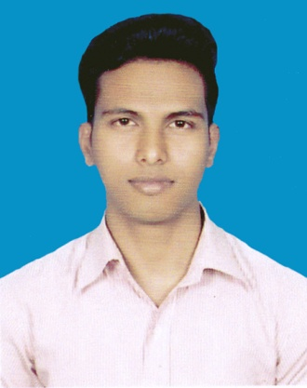
MD. masud hasan

Picture
Contact Address
01767025998
01635429009
6468.mh@gmail.com
Imandipur,Savar,Dhaka-1340

Career Objective | To work with a challenging, growing and developing organization where there is a strong cultural environment of accepting, sharing and rewarding better ideas and which can offer a wide ground of performance with prudence, sincerity, honesty and efficiency.
Achievements  Skills  Computer knowledge  Interests  Vocational Qualification | - Re-organized something to make it work better  - Identified a problem and solved it  - Come up with a new idea that improved things  - Developed or implemented new procedures or systems  - Worked on special projects  - Saved money for the company  - Saved time for the company  - Contributed to good customer service  - Communication.  - Ability to Work under Pressure.  - Decision Making.  - Time Management.  - Self-motivation.  - Conflict Resolution.  - Leadership  Ability to work with windows 7, windows 10, Microsoft office (world, excel, power point and Photoshop).  Dealings with People & Doing challenging jobs with target. Interest to research works in Fashion developing & Traveling.  Institution/Organization Society for Underprivileged Families - SUF  Name of Trade Garments Quality Control and Finishing  Duration 06 Month  Grade A+
Institution/Organization National Institute of Fashion Technology (NIFT)
Name of Trade Pattern making, cutting and grading
Duration 06 Month
Grade published not yet

Personal Profile  Education  Reference | Father’s Name Md.Tojammel Haque  Mother’s Name Mst. Shahina Begum  Date of Birth 04, September, 1995  Nationality Bangladeshi by Birth  Marital Status Single  Religion Islam  Sex Male  Permanent Address Village:Shreekhata,  Post Dalgram  Police station Kaliganj  District Lalmonirhat  Division Rangpur  National Id No 8657194505  B.s.c (Hons) in Apparel manufacture & Technology  03rd semester completed  04th semester running  Up to 08 semester  CGPA=3.00 out of scale 4  Passing year = appeared  SONARGAON UNIVERSITY (SU)  Diploma In Garments Design & Pattern Making  GPA = 3.35 out of scale 4  Passing year = 2017  NATIONAL INSTITUTE OF ENGINEERING AND TECHNOLOGY (NIET)  Secondary School certificate(SSC)  GPA = 4.77 out of scale 5  Passing year = 2012  CHAPARHAT TECHNICAL & BM COLLAGE  MD. PARVES AHMED  Assistant Manager (Planning). Pakiza Knit (Garments).  Address: IMANDIPUR (GABTOLA), SAVAR, DHAKA.  Cell: 01786180038  Relation : Personal  E-mail : parves@pakizaknit.com

---------------------------
Md. Masud Hasan

