Resume
Md Ismail Hossain  Diploma in Electrical Engineer | 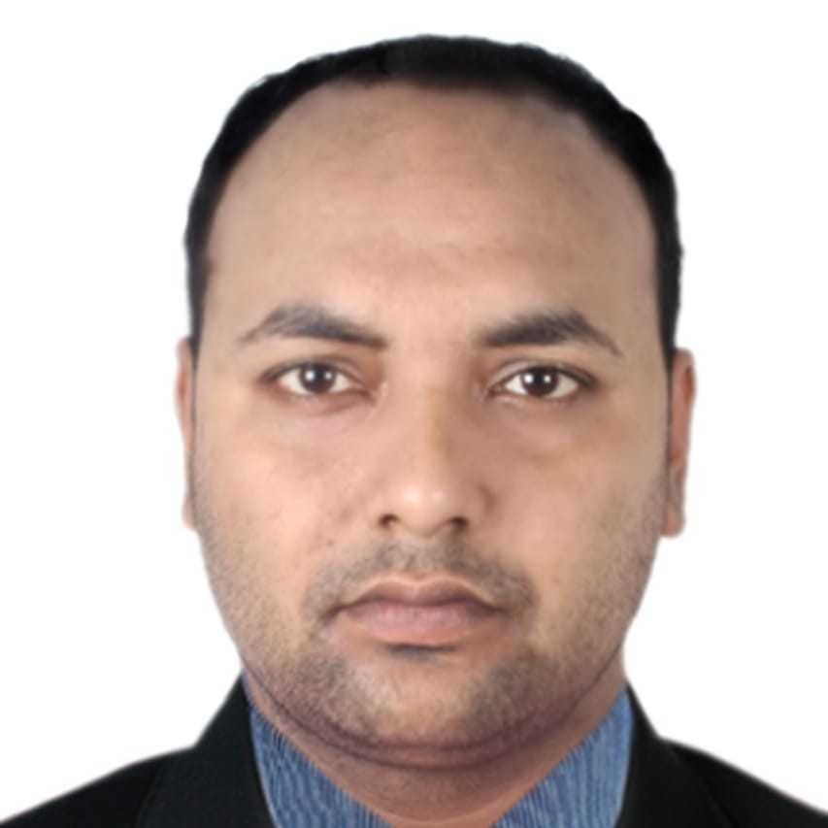 |  Village:kamala pur (sundor ali member bari) P.O:Sharat Nagor,  Adrsha Sadar Cumilla, Chittagong Division Bangladesh   Do   +880 1737089809, +880 1830091304    ismailhossain8116@yahoo.com , enggmdismail@gmail.com  僧 15 Feb 1993  Cumilla   Unmarried   Bangladeshi

OBJECTIVE


Advertising professional who sold 16 Million taka in power storage (Battery) products per month using an innovative launch campaign and strong leaderships skills.
Seeking a sales manager position where can further apply my skills, while increasing the company's bottom line.

RESPONSIBILITIES

○
➤Establishing action plans to drive the performance of sales & Meeting sales goals
➤Developing productive relationships with work colleagues & Staff Management
➤Always monitoring new developments in the retail sector.
➤Developing initiating and maintaining complex filing systems.
➤Analysing sales figures and forecasting future sales volumes to maximise profits.
➤Managing Teritory, Stock, service issues,Distbruation followup regularly.
➤Tracking KPIs daily/weekly/monthly.
➤Maintaining strong relationships with customers and creating new customers.
➤ communication across all customers during various offers & motivate regarding revenue opportunities.
➤Monitor analytics to understand best practices.
➤Increases Sales, Margins and also Selling to Customers
➤Developing Initiatives, Identifying Market Trends

EXPERIENCE


Unit In Charge / 02 December 2015-29 260/B,5th Floor Tejgaon industrial area Dhaka 1208
January 2019

Rahimafrooz Renewable Energy Ltd
Fleet Management Executive, Oparation / 04 Navana pristeal pavellion, gulsan 2 dhaka
February 2019-28 March 2020

Foodpanda Bangladesh Ltd
DSM (Divisional Sales Manager) / 01 Subhanallah super market, Koiline, Chandina,Cumilla June 2019-Present

Shikder Chemical Works

EDUCATION


Bsc in EEE / 2017 Cumilla,Kotbari

CCN Science & Technology University
I am on the way of completing Bsc Engineering from CCN Science & Technology University With the subject of Electrical & Electronic Engineering .
Diploma In Engineering / 2010-2015 Kotbari Cumilla

CCN Polytechnic Institute, (Kotbari,Cumilla)
I completed the degree of Diploma in Electrical Engineering with CGPA 3.17 Out of 4 in 2015.
SSC (Secondary Sayed Pur,Sharat Nagar, Adrsha Sadar Cumilla, Chittagong, Bangladesh School Certificate)
/ 2007-2009
Sayed Pur High

School
I passed the SSC exam from Science Background in 2009 with GPA 4.56 Out of 5

PERSONAL SKILLS



Knowledge on Job duration :
➤Good attention to detail with a High level of accuracy.
➤Highly creative with experience in identifying target audiences and devising digital campaigns.
➤Highly capable of convince any person and presenting new creative growth strategies
➤Experience in retail sales and excellent skills in market analysis on time.
➤Excellent written and verbal communication skills as well as strong time management skills.

Skills in Internet & inventory / December 2018-February 2019 25 members

Iqra cumputer & traning center

Learned Below topic :-
➤Knowledge on work in automation system & Provide all reports (stock, inventory)
➤Good communication skills like E-mail, Internet and also ability to work all windows system.
➤Excelent work knowledge in E commerce system (online base activities)
➤On necessary work or report by using Microsoft software (MS Word, MS Excel, Power Point presentation)

PROFESSIONAL SKILLS


Areas of Excellency , Excellent ➤

➤Market & Competitive Analysis
➤Sales Training, Leadership & Operational Management
➤Customer Relationship Management & Distribution Channel Management
➤New Product Planning & Business Development.
➤Strategic Alliances, Strategic Marketing & Product Positioning.

COURSES


Microsoft Office Near Govt Laboratory high school, kotbari, cumilla, Chittagong Bangladesh
Application / 3 months
Abdulla
Computer &

Traning Center

I have learned below Programmes-
➤Microsoft software (Microsoft Excel, Word & Power Point)
➤ Windows System Update / Install & Gained knowledge in Hardware system
➤ Internet Browser as well as proper offical cummnucation Through E-mail, Letter & Fax etc
Spoken English / 3 Near Rampura primary school,gondhamoti,kotbari cumilla,Chittagong months
Wonderful Method for

Speaking english
I have gained knowledge in below areas:-
➤How to discuss with others by using international languge (english).
➤How to convene someone easily in english.
➤The best commination process at any where, at any situation with any whom .
Management Skills / 15 days Kotbari, Cumilla, Chittagong, Bangladesh

BARD(Bangladesh Academy for Rural Development)

Major Discussion Areas :-
➤ Understand the organizations situation with current activities .
➤ Manage any critical period in industries
➤Make new plan for easily convince employees
➤ Maintaining categories wise employees works & ensure right person working in right place / sector
➤ Operate the oparation sector following by chain & command.

Industrial Attachment Eastern tube (Opposit of BSTI bavan), Tejgaon industrial area Dhaka. / Training / 6 months BSEC (Bangladesh steel & Engineering Corporation)

Trianing areas were :-
➤ Observation 440 volt line & electriacl Panel board
➤ calculated input, export products as well as waste quantity
➤ Chemical Combination process & The workness of each & every machines
➤ The process of making a tube Light.

PROJECTS

類
Surjo Chowla in rural platform / 10 January 42 (people / employees worked in this Project
2016-11 March 2016

Rahimafrooz Renewable Energy Ltd (RSF)
To ensure the Knowledge of using natural power (sun) we can save nature, economic as well as develop by self.
Acknowledgment to Robar Scoud team Necessary and Achievement by 50 (Fifty) naturally / 01 January 2017-10 January 2017 RSF (Rural Service Foundation)

 ACHIEVEMENTS AND AWARDS
Best DSP In-Charge / June 2018
I was selected best (nationally) DSP Incharge ( Distbruation & Service point) for area of 'Hobigonj & B-Baria ' Distric.

Award for turn over sales volume / September 2018
I received an award for potential market & provide huge profit to company from my job location areas. i turned over on average 15 lacks taka sales per month.

Fleet of The Year ( FOODPAND) / January 2019
☞ That period i was working in foodpanda Bangladesh Ltd as a fleet management Executive, Operation Determent in Cumilla City.
My city reached in number 01 (First position) after 41 days of launching the cumilla city. i worked with my team member & took necessary steps to improve by new plan .

LANGUAGES

Bengli ,

Excellent
English
,

very Good

Hindi
,

Good

HOBBIES AND INTERESTS

Travelling, Playing Cricket, Reading Newspaper, Interest in team work




REFERENCES

Mr Al Amin
Rahimafrooz Renewable Energy Ltd
Area Manager 8801721256827
aminal501@yahoo.com
260/B,5th floor Tejgaon industrial area Dhaka 1208


Date :

27
July
2020
Place :

Cumilla
Md Ismail Hossain

