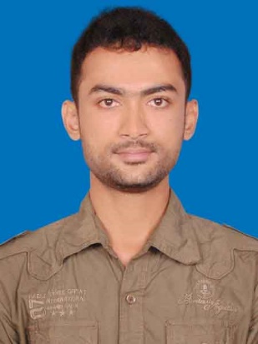
Curriculum Vitae
Of
Md. Badiuzzaman Biplob

Mobile: +8801818892543
E-mail: biplob.cse45@gmail.com
Website: http://biplob.wordpressctg.com/

Career Objectives
To pursue career as a professional in a reputed company where there is an opportunity of self-assessment and self-improvement in both engineering and creative jobs and to show my immense aspiration to become a quick learner and to prove myself as a sincere and energetic person through extensive hard working and integrity that will ultimately lead to the further development of the organization and me.

- Educational Background:

B.Sc. in Computer Science & Engineering
Institute | : | International Islamic University Chittagong.
Department | : | Computer Science & Engineering.
Result | : | CGPA 3.83 in the scale of 4.00as a regular examinee in the last 8 semesters.

Higher Secondary School Certificate (HSC)
Institute | : | B.N School & College, Chittagong.
Department | : | Science.
Result | : | GPA 4.70 in the scale of 5.00 as a regular examinee.
Passing year | : | 2012

Secondary School Certificate (SSC)
Institute | : | B.N School & College, Chittagong.
Department | : | Science.
Result | : | GPA 4.75 in the scale of 5.00 as a regular examinee.
Passing year | : | 2010

- Computer Skill:

Programming language : Html, CSS, Php, Java Script, WordPress, Ruby, Rails.

- Personal Strength:

- Mentionable proficiency over English & Bengali.
- Self-motivated and willing to work in a challenging environment.
- Work good in team and can take responsibility independently.
- Good interpersonal relation building capability, deal efficiently with community.

- Working Experiences:

- In 4th semester I've made a game using java programming language.
- In 5th semester me and my team members created a web based project using Html, Css, JS, Python, Django, Sqlite .Our Project name is: "Online BO.Account Opening and share trading".
- In 5th semester I've also done a project in Microprocessor subject.
- In 6th semester me and my team member again created a web based project using Html, Css, JS, Jquery, Bootstarp, Php, Mysql.Our Project name is: "Geolocation Based Online Blood Bank System".

Training:

- Web Development at “Synchronise IT” ,
- Spoken English at Executive Care(An English Language Center) ,
- Web Application Development Dot Net at BITM,
- Wordpress at “Desh IT” Top-Up IT Training of ICT.

- Personal Information :

Name  Father’s Name | :  : | Md. Badiuzzaman Biplob  Md. Tozzammel Haque
Mother’s name | : | Mrs. Beauty Ara Bibi
Date of birth | : | 1st November 1995
Permanent Address | : | Village-Ramkrishnopur, District-Dinajpur, Thana-Birampur, P.O-Kundonhat, Division-Rangpur.
Nationality | : | Bangladeshi
Religion | : | Islam
Marital Status | : | Unmarried

I am declaring that so far I know all the information given here is true.

Md. Badiuzzaman Biplob

