1st June, 2018

CEO, Staff-India,
601 International House,
London W1B 2QD.

Subject: Application for the post of “SENIOR WORDPRESS DEVELOPER”

Dear Sir,

In response to your advertisement published that you are going to recruit some “SENIOR WORDPRESS DEVELOPER”. With the respect, I would like to offer myself as an eligible candidate for the same post. I am enclosed herewith a complete set CV for your kind consideration.

So, I therefore pray and hope that you would be kind enough to consider me for the very position.

Thank you,

Yours truly,

Md. Badiuzzaman Biplob

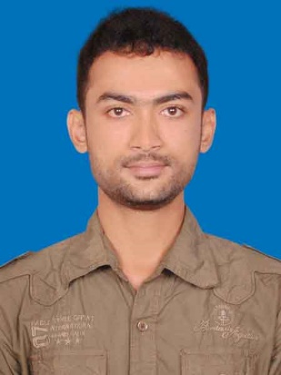
Curriculum Vitae
Of
Md. Badiuzzaman Biplob

Mobile: +8801818892543
E-mail: biplob.cse45@gmail.com
Website: http://biplob.wordpressctg.com/

Career Objectives
To pursue career as a professional in a reputed company where there is an opportunity of self-assessment and self-improvement in both engineering and creative jobs and to show my immense aspiration to become a quick learner and to prove myself as a sincere and energetic person through extensive hard working and integrity that will ultimately lead to the further development of the organization and me.

- Educational Background:

B.Sc. in Computer Science & Engineering
Institute | : | International Islamic University Chittagong.
Department | : | Computer Science & Engineering.
Result | : | CGPA 3.83 in the scale of 4.00as a regular examinee

Higher Secondary School Certificate (HSC)
Institute | : | B.N School & College, Chittagong.
Department | : | Science.
Result | : | GPA 4.70 in the scale of 5.00 as a regular examinee.
Passing year | : | 2012

Secondary School Certificate (SSC)
Institute | : | B.N School & College, Chittagong.
Department | : | Science.
Result | : | GPA 4.75 in the scale of 5.00 as a regular examinee.
Passing year | : | 2010

- Computer Skill:

Programming language: Html, CSS, Php, JavaScript, WordPress, Ruby, Rails, CPA.

- Personal Strength:

- Mentionable proficiency in English & Bengali.
- Self-motivated and willing to work in a challenging environment.
- Work good in the team and can take responsibility independently.
- Good interpersonal relationship building capability, deal efficiently with community.

- Working Experiences:

- In 4th semester I've made a game using java programming language.
- In 5th semester me and my team members created a web-based project using Html, CSS, JS, Python, Django, SQLite. Our Project name is: "Online BO. Account Opening and share trading".
- In 5th semester I've also done a project in Microprocessor subject.
- In 6th semester me and my team member again created a web-based project using Html, CSS, JS, Jquery, Bootstrap, Php, Mysql. Our Project name is: "Geolocation Based Online Blood Bank System".
- Completed my final year thesis paper which is based on Data Mining and topic name is: “Development of an Efficient Extraction, Transformation and Loading (E-ETL) Technique for Data Warehouses”.
- I Created 4 WordPress site. BDMagazineNews, Online Shop,Desi Shop, Portfolio Site
Linkedin Link: https://www.linkedin.com/in/md-badiuzzaman-biplob-1196a0119/
- Also Created 4 Website based on Ruby On Rails
Github Link: https://github.com/Biplob45

Training:

- Web Development at “Synchronise IT” ,
- Spoken English at Executive Care(An English Language Center) ,
- Web Application Development Dot Net at BITM,
- Wordpress at “Desh IT” Top-Up IT Training of ICT.

- Personal Information :

Name  Father’s Name | :  : | Md. Badiuzzaman Biplob  Md. Tozzammel Haque
Mother’s name | : | Mrs. Beauty Ara Bibi
Date of birth | : | 1st November 1995
Permanent Address | : | Village-Ramkrishnopur, District-Dinajpur, Thana-Birampur, P.O-Kundonhat, Division-Rangpur.
Nationality | : | Bangladeshi
Religion | : | Islam
Marital Status | : | Unmarried

I am declaring that so far I know all the information given here is true.

Md. Badiuzzaman Biplob

